# Sites that were included

NSABBS0002 Test Set: (Timestamp('2003-08-12 00:00:00'), Timestamp('2005-11-05 00:00:00')), Period: 78  
  
NSTSYB0001 Test Set: (Timestamp('2018-03-24 00:00:00'), Timestamp('2020-04-05 00:00:00')), Period: 77  
  
NSTSYB0003 Test Set: (Timestamp('2007-12-22 00:00:00'), Timestamp('2011-02-24 00:00:00')), Period: 64  
  
NSTSYB0009 Test Set: (Timestamp('2017-01-15 00:00:00'), Timestamp('2020-02-01 00:00:00')), Period: 52  
  
SAAEYB0002 Test Set: (Timestamp('2020-05-16 00:00:00'), Timestamp('2022-12-24 00:00:00')), Period: 55  
  
SAAEYB0004 Test Set: (Timestamp('2006-08-30 00:00:00'), Timestamp('2009-01-10 00:00:00')), Period: 50  
  
SAAEYB0006 Test Set: (Timestamp('1987-09-11 00:00:00'), Timestamp('1993-11-14 00:00:00')), Period: 51  
  
SAAEYB0007 Test Set: (Timestamp('2012-07-05 00:00:00'), Timestamp('2015-10-02 00:00:00')), Period: 57  
  
SAAEYB0008 Test Set: (Timestamp('2012-09-07 00:00:00'), Timestamp('2015-05-27 00:00:00')), Period: 52  
  
SAAEYB0009 Test Set: (Timestamp('1998-10-11 00:00:00'), Timestamp('2004-01-05 00:00:00')), Period: 59  
  
SAAEYB0010 Test Set: (Timestamp('2006-11-18 00:00:00'), Timestamp('2009-08-30 00:00:00')), Period: 55  
  
SAAEYB0011 Test Set: (Timestamp('2012-06-19 00:00:00'), Timestamp('2015-02-28 00:00:00')), Period: 51  
  
SAAEYB0012 Test Set: (Timestamp('2015-11-19 00:00:00'), Timestamp('2018-04-25 00:00:00')), Period: 54  
  
SAAEYB0013 Test Set: (Timestamp('2015-08-15 00:00:00'), Timestamp('2017-12-10 00:00:00')), Period: 53  
  
SAAEYB0021 Test Set: (Timestamp('2017-12-25 00:00:00'), Timestamp('2020-01-24 00:00:00')), Period: 59  
  
SAAEYB0022 Test Set: (Timestamp('1998-12-05 00:00:00'), Timestamp('2003-07-20 00:00:00')), Period: 61  
  
SAAEYB0023 Test Set: (Timestamp('2011-09-28 00:00:00'), Timestamp('2015-03-31 00:00:00')), Period: 60  
  
SAAEYB0025 Test Set: (Timestamp('2003-12-27 00:00:00'), Timestamp('2006-07-12 00:00:00')), Period: 88  
  
SAAEYB0026 Test Set: (Timestamp('2014-02-24 00:00:00'), Timestamp('2016-11-27 00:00:00')), Period: 82  
  
SAAEYB0027 Test Set: (Timestamp('2018-11-17 00:00:00'), Timestamp('2020-09-03 00:00:00')), Period: 77  
  
SAAEYB0028 Test Set: (Timestamp('2020-09-04 00:00:00'), Timestamp('2022-12-31 00:00:00')), Period: 62  
  
SAAEYB0030 Test Set: (Timestamp('1992-08-07 00:00:00'), Timestamp('1999-03-11 00:00:00')), Period: 107  
  
SAAEYB0031 Test Set: (Timestamp('2017-09-12 00:00:00'), Timestamp('2020-02-26 00:00:00')), Period: 127  
  
SAAKAN0002 Test Set: (Timestamp('2000-02-11 00:00:00'), Timestamp('2004-05-28 00:00:00')), Period: 44  
  
SAAKAN0004 Test Set: (Timestamp('1987-09-11 00:00:00'), Timestamp('1994-01-17 00:00:00')), Period: 44  
  
SAAKAN0005 Test Set: (Timestamp('2020-03-29 00:00:00'), Timestamp('2022-12-24 00:00:00')), Period: 37  
  
SAAKAN0006 Test Set: (Timestamp('2006-08-22 00:00:00'), Timestamp('2009-03-23 00:00:00')), Period: 41  
  
SAAKAN0007 Test Set: (Timestamp('2004-12-22 00:00:00'), Timestamp('2007-11-29 00:00:00')), Period: 49  
  
SAAKAN0008 Test Set: (Timestamp('1987-09-11 00:00:00'), Timestamp('1993-02-15 00:00:00')), Period: 55  
  
SAAKAN0009 Test Set: (Timestamp('2014-10-31 00:00:00'), Timestamp('2017-12-10 00:00:00')), Period: 39  
  
SAAKAN0010 Test Set: (Timestamp('2015-07-15 00:00:00'), Timestamp('2017-12-26 00:00:00')), Period: 79  
  
SAAKAN0012 Test Set: (Timestamp('2000-05-10 00:00:00'), Timestamp('2004-08-08 00:00:00')), Period: 86  
  
SAAMDD0011 Test Set: (Timestamp('1993-10-05 00:00:00'), Timestamp('1999-10-15 00:00:00')), Period: 71  
  
SATFLB0002 Test Set: (Timestamp('2015-06-05 00:00:00'), Timestamp('2018-01-04 00:00:00')), Period: 56  
  
TCABEL0002 Test Set: (Timestamp('2003-11-25 00:00:00'), Timestamp('2006-01-01 00:00:00')), Period: 42  
  
TCATCH0001 Test Set: (Timestamp('1992-12-20 00:00:00'), Timestamp('1996-08-09 00:00:00')), Period: 72  
  
TCATCH0007 Test Set: (Timestamp('2017-10-06 00:00:00'), Timestamp('2020-05-22 00:00:00')), Period: 76  
  
VCAAUA0004 Test Set: (Timestamp('2008-03-10 00:00:00'), Timestamp('2011-03-27 00:00:00')), Period: 59  
  
VCAAUA0008 Test Set: (Timestamp('1998-01-10 00:00:00'), Timestamp('2003-01-16 00:00:00')), Period: 60  
  
VCAAUA0009 Test Set: (Timestamp('2005-05-13 00:00:00'), Timestamp('2008-01-14 00:00:00')), Period: 57  
  
WAAAVW0001 Test Set: (Timestamp('1993-01-02 00:00:00'), Timestamp('1998-01-23 00:00:00')), Period: 130  
  
WAAAVW0002 Test Set: (Timestamp('1998-06-16 00:00:00'), Timestamp('2003-07-25 00:00:00')), Period: 134  
  
WAAAVW0007 Test Set: (Timestamp('2004-01-07 00:00:00'), Timestamp('2006-07-07 00:00:00')), Period: 85  
  
WAACOO0001 Test Set: (Timestamp('2007-01-01 00:00:00'), Timestamp('2009-10-29 00:00:00')), Period: 76  
  
WAACOO0003 Test Set: (Timestamp('2004-02-02 00:00:00'), Timestamp('2006-11-22 00:00:00')), Period: 76  
  
WAACOO0004 Test Set: (Timestamp('1987-09-15 00:00:00'), Timestamp('1993-11-02 00:00:00')), Period: 76  
  
WAACOO0006 Test Set: (Timestamp('2009-10-05 00:00:00'), Timestamp('2013-07-20 00:00:00')), Period: 76  
  
WAACOO0007 Test Set: (Timestamp('2009-05-30 00:00:00'), Timestamp('2013-03-22 00:00:00')), Period: 75  
  
WAAESP0001 Test Set: (Timestamp('2020-05-11 00:00:00'), Timestamp('2022-12-19 00:00:00')), Period: 55  
  
WAAGES0001 Test Set: (Timestamp('2006-02-19 00:00:00'), Timestamp('2009-02-19 00:00:00')), Period: 85  
  
WAAGES0002 Test Set: (Timestamp('2012-11-26 00:00:00'), Timestamp('2015-08-07 00:00:00')), Period: 85  
  
WAAGES0003 Test Set: (Timestamp('1993-07-09 00:00:00'), Timestamp('1999-04-21 00:00:00')), Period: 86  
  
WAAGES0005 Test Set: (Timestamp('2020-04-14 00:00:00'), Timestamp('2022-12-16 00:00:00')), Period: 87  
  
WAAJAF0001 Test Set: (Timestamp('2009-11-29 00:00:00'), Timestamp('2013-07-27 00:00:00')), Period: 47  
  
WAAJAF0003 Test Set: (Timestamp('2009-09-18 00:00:00'), Timestamp('2013-04-03 00:00:00')), Period: 54  
  
WAAMAL0002 Test Set: (Timestamp('2015-02-16 00:00:00'), Timestamp('2017-11-04 00:00:00')), Period: 69  
  
WAAMAL0003 Test Set: (Timestamp('1987-09-15 00:00:00'), Timestamp('1994-04-11 00:00:00')), Period: 69  
  
WAAYAL0008 Test Set: (Timestamp('1993-08-28 00:00:00'), Timestamp('1999-06-26 00:00:00')), Period: 87

# Table: MSE of the Random Forest on each output

|  |  |  |  |  |
| --- | --- | --- | --- | --- |
|  | pv_filter | npv_filter | bs_filter | loss_mean |
| Train | 1.453 | 1.338 | 1.829 | 1.54 |
| Test | 21.068 | 21.299 | 26.078 | 22.815 |

# Permutation Importance

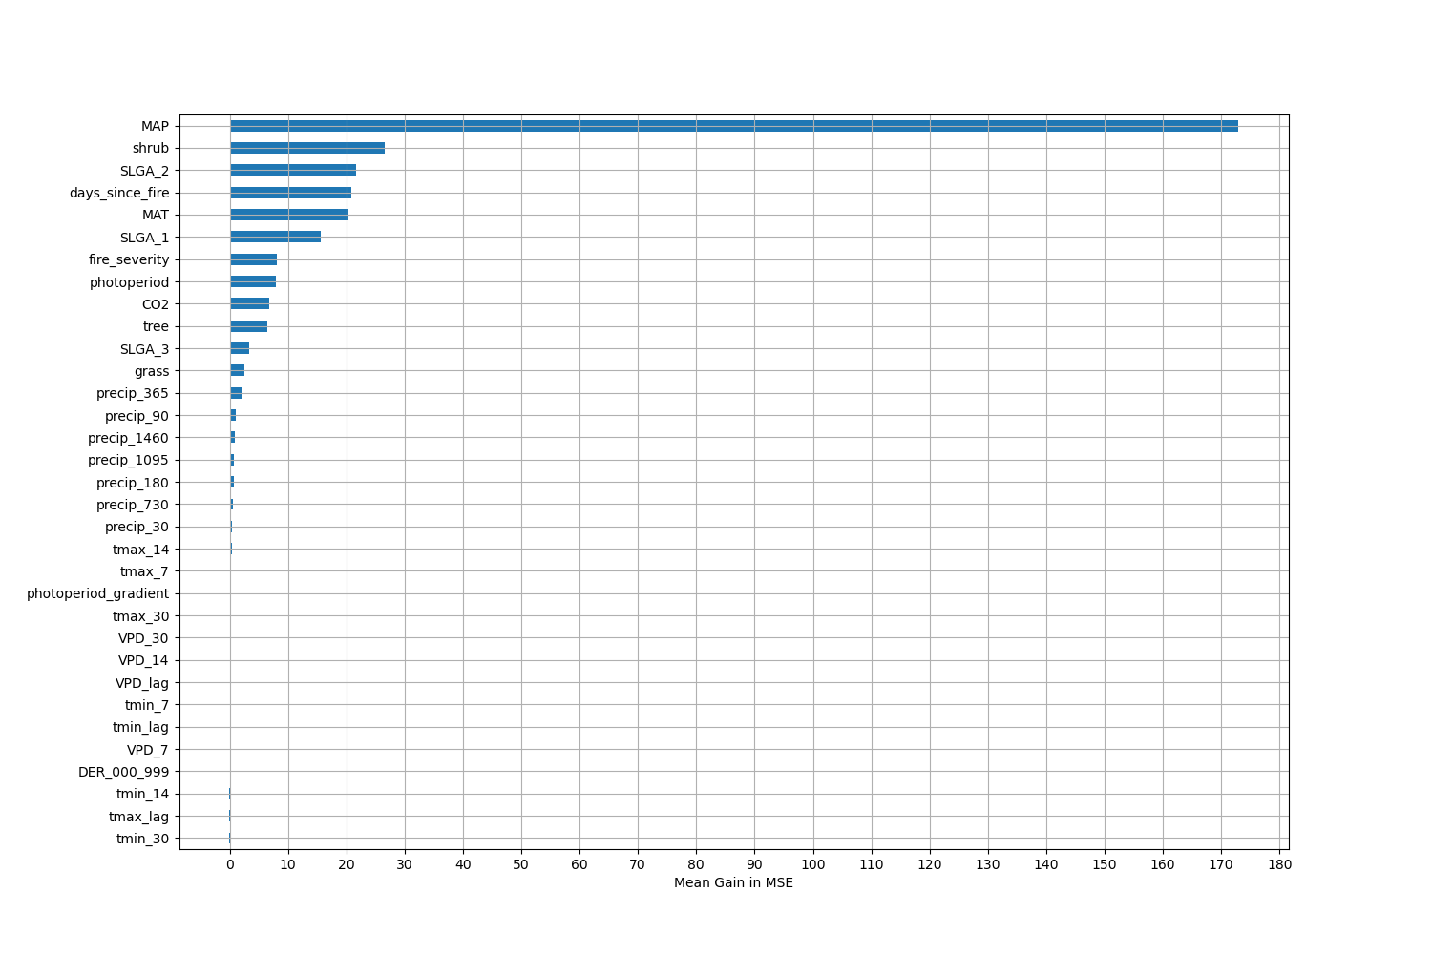

# Permutation Importance by Precip

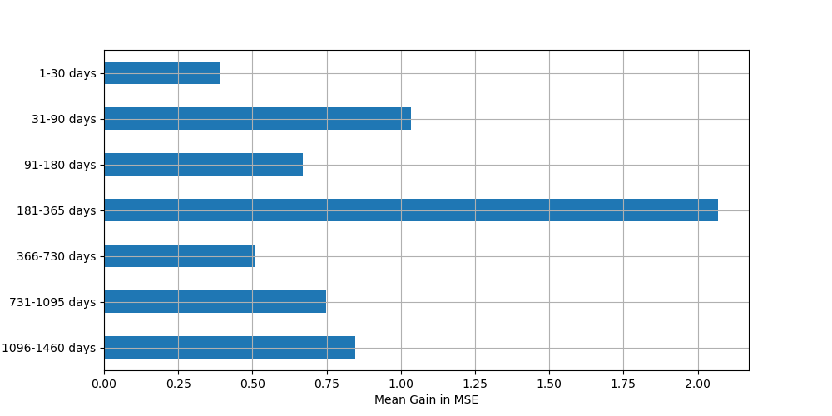

# ALE Importance

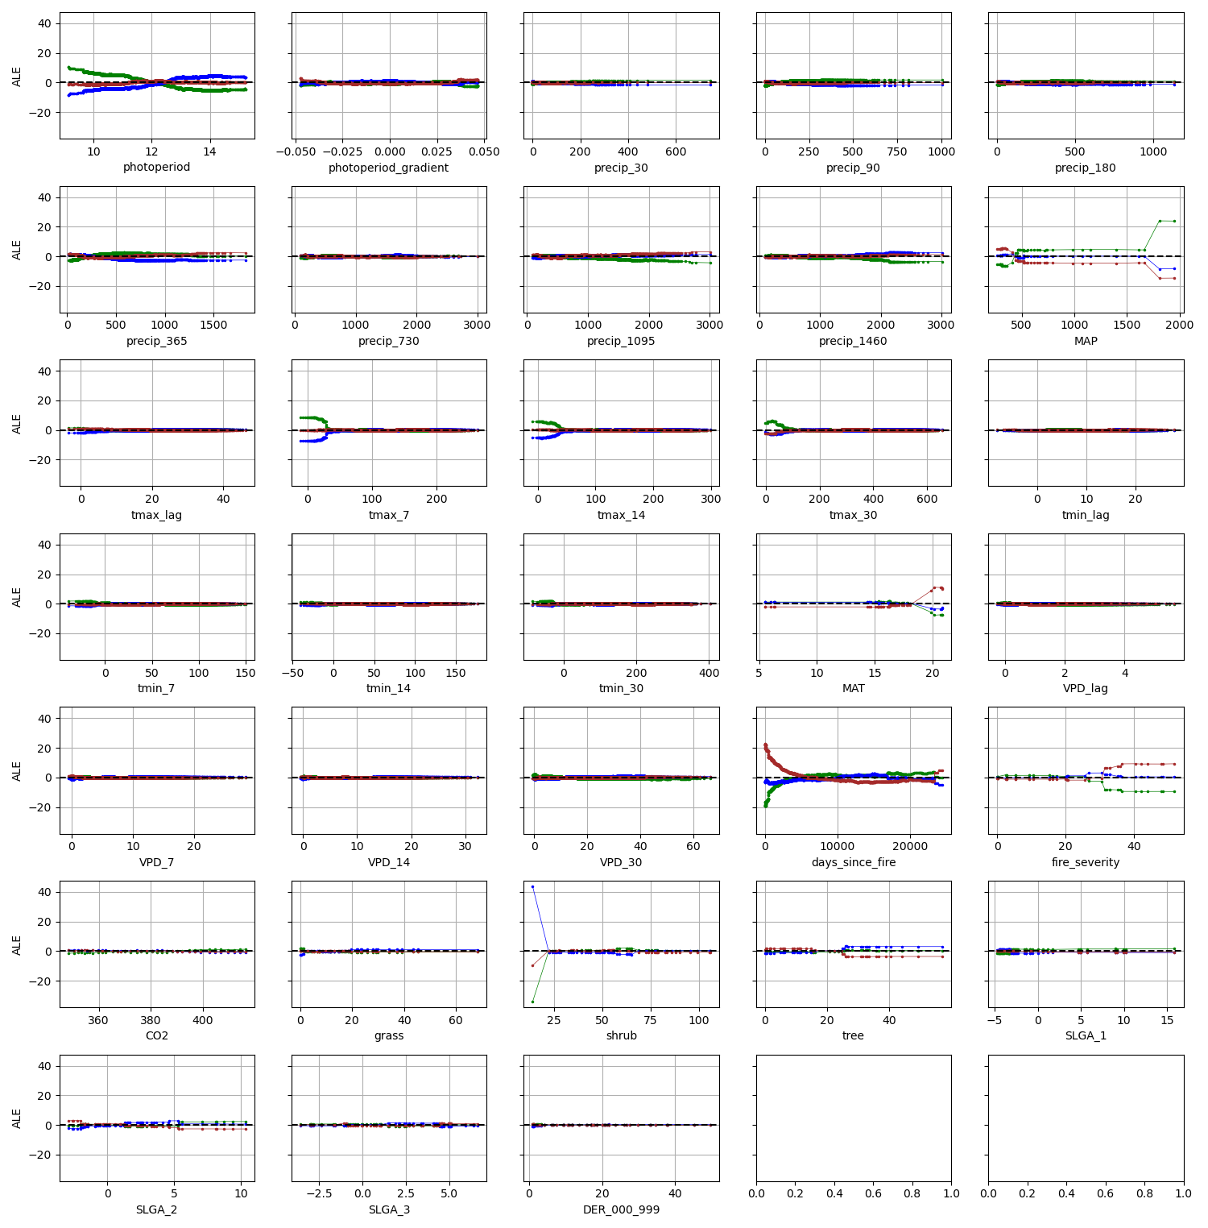

# NSABBS0002

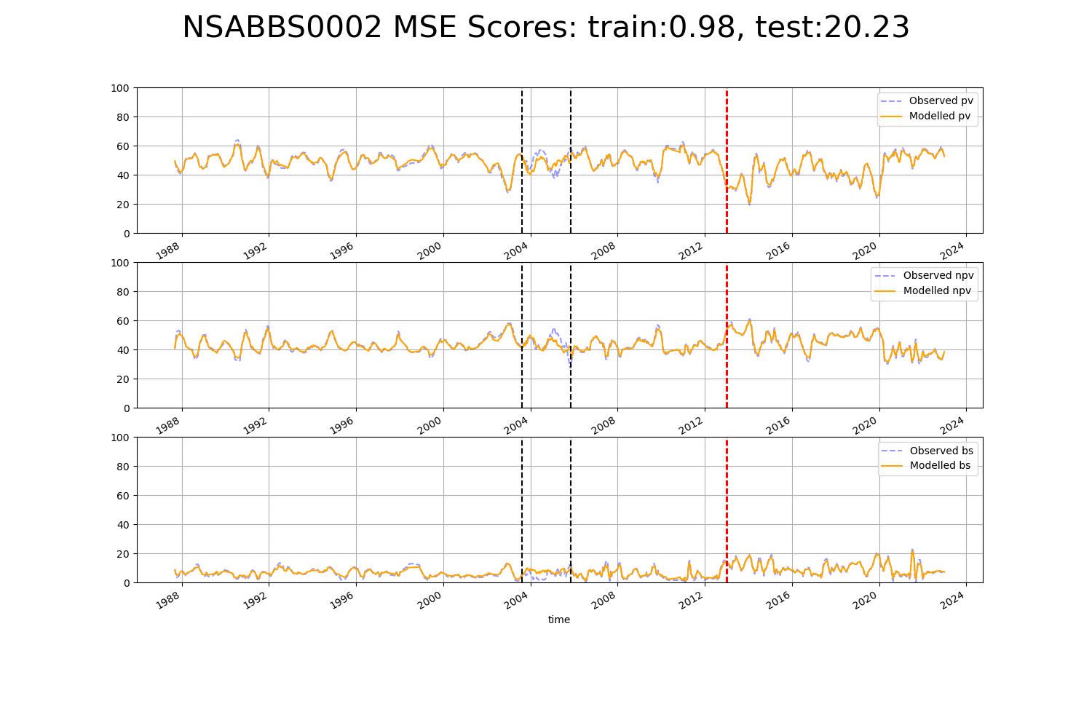

# NSTSYB0001

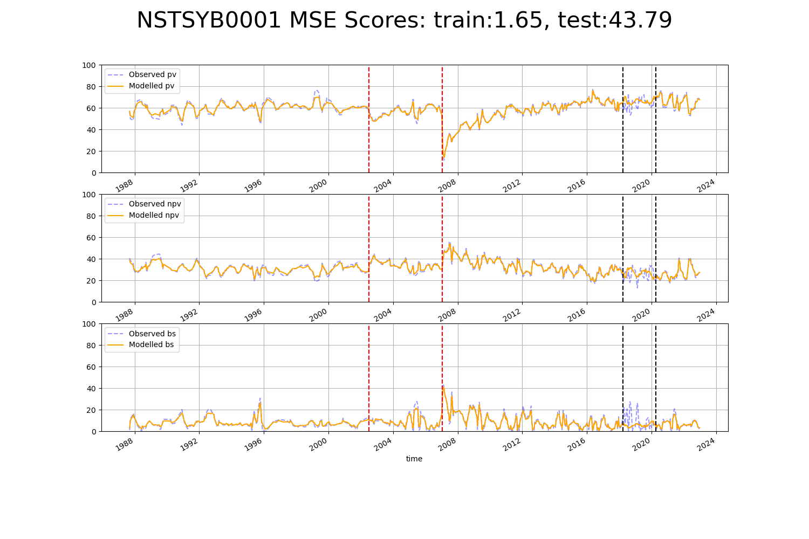

# NSTSYB0003

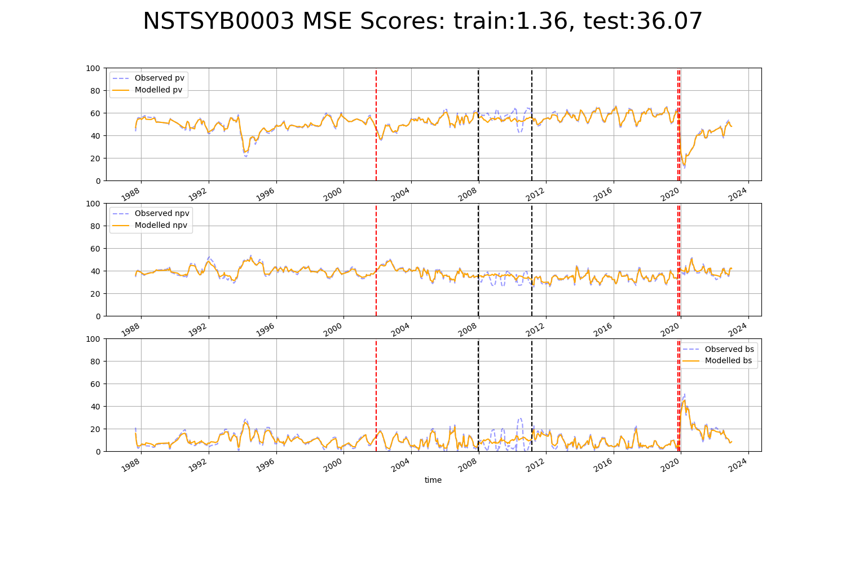

# NSTSYB0009

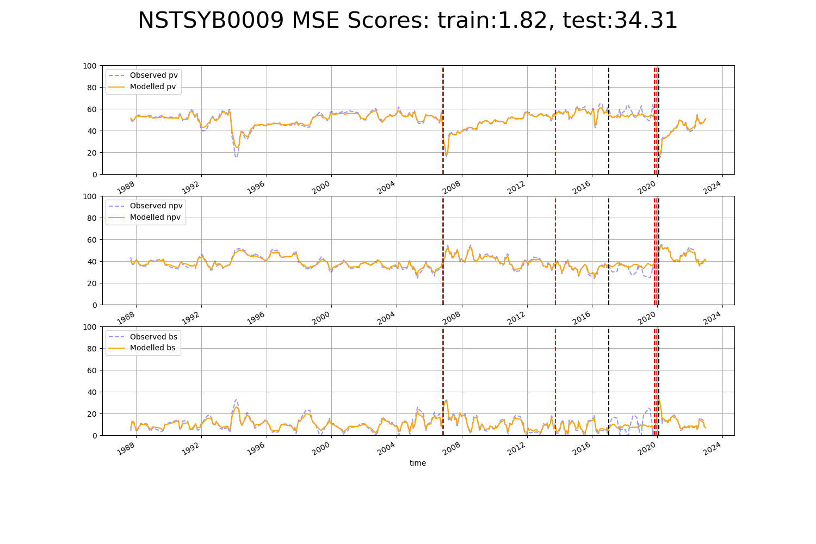

# SAAEYB0002

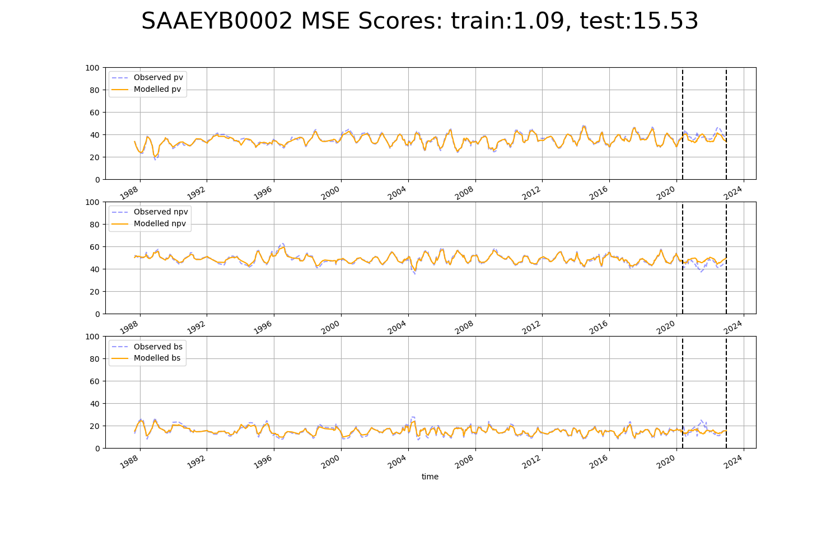

# SAAEYB0004

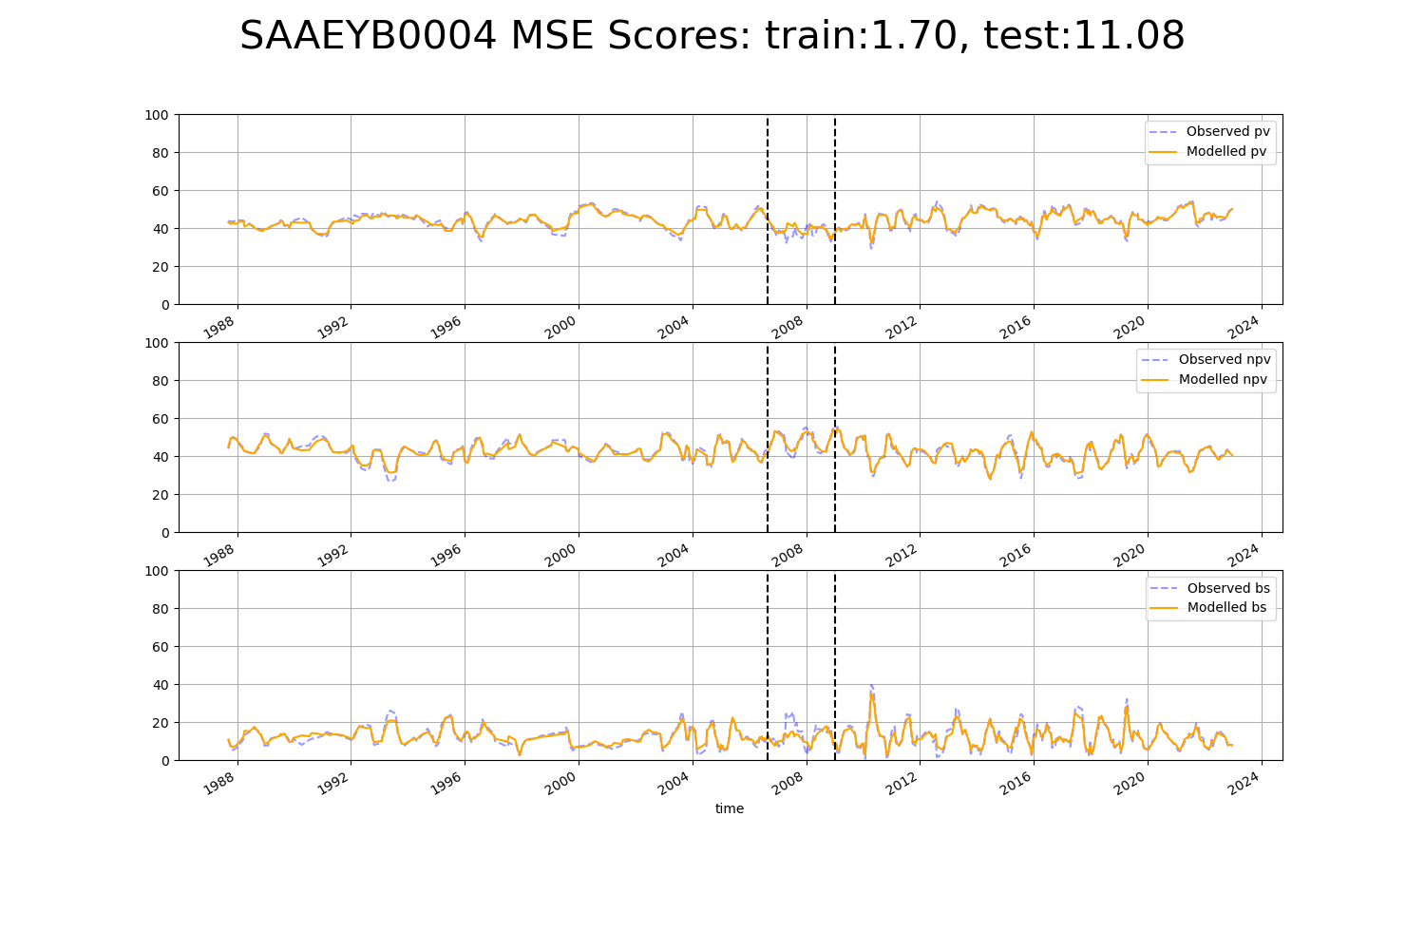

# SAAEYB0006

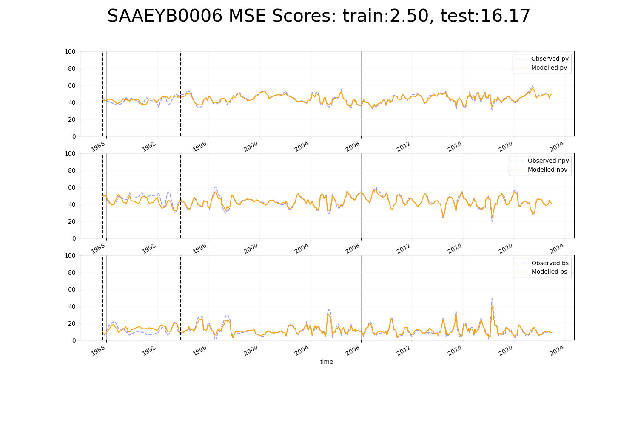

# SAAEYB0007

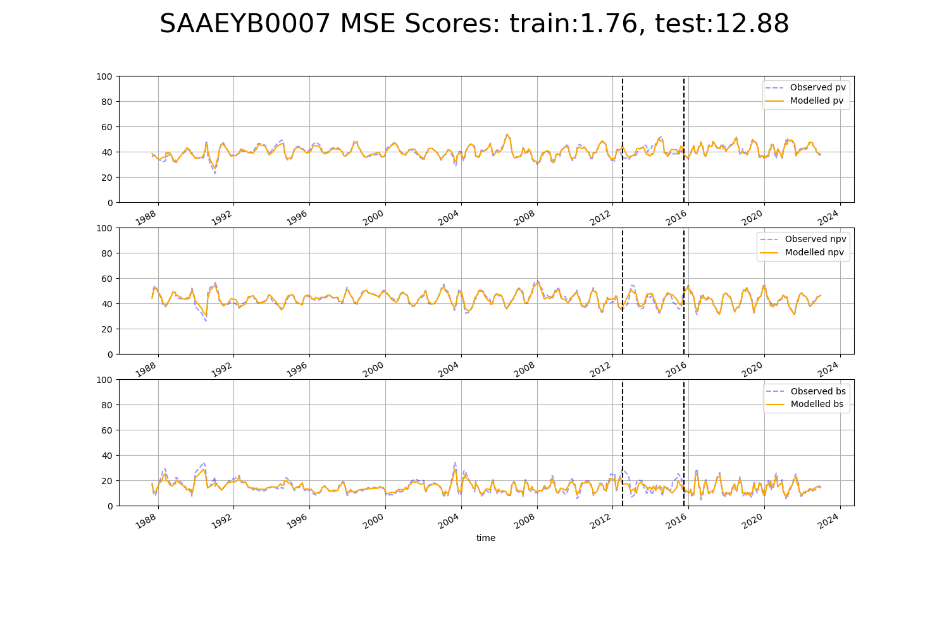

# SAAEYB0008

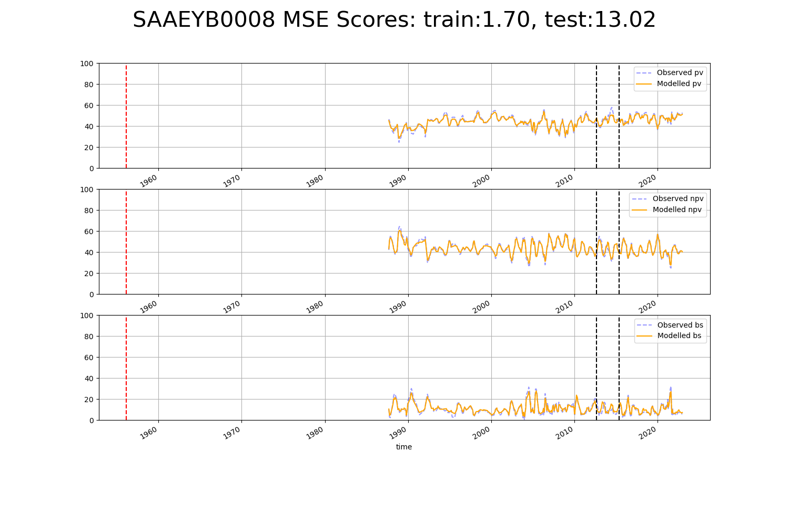

# SAAEYB0009

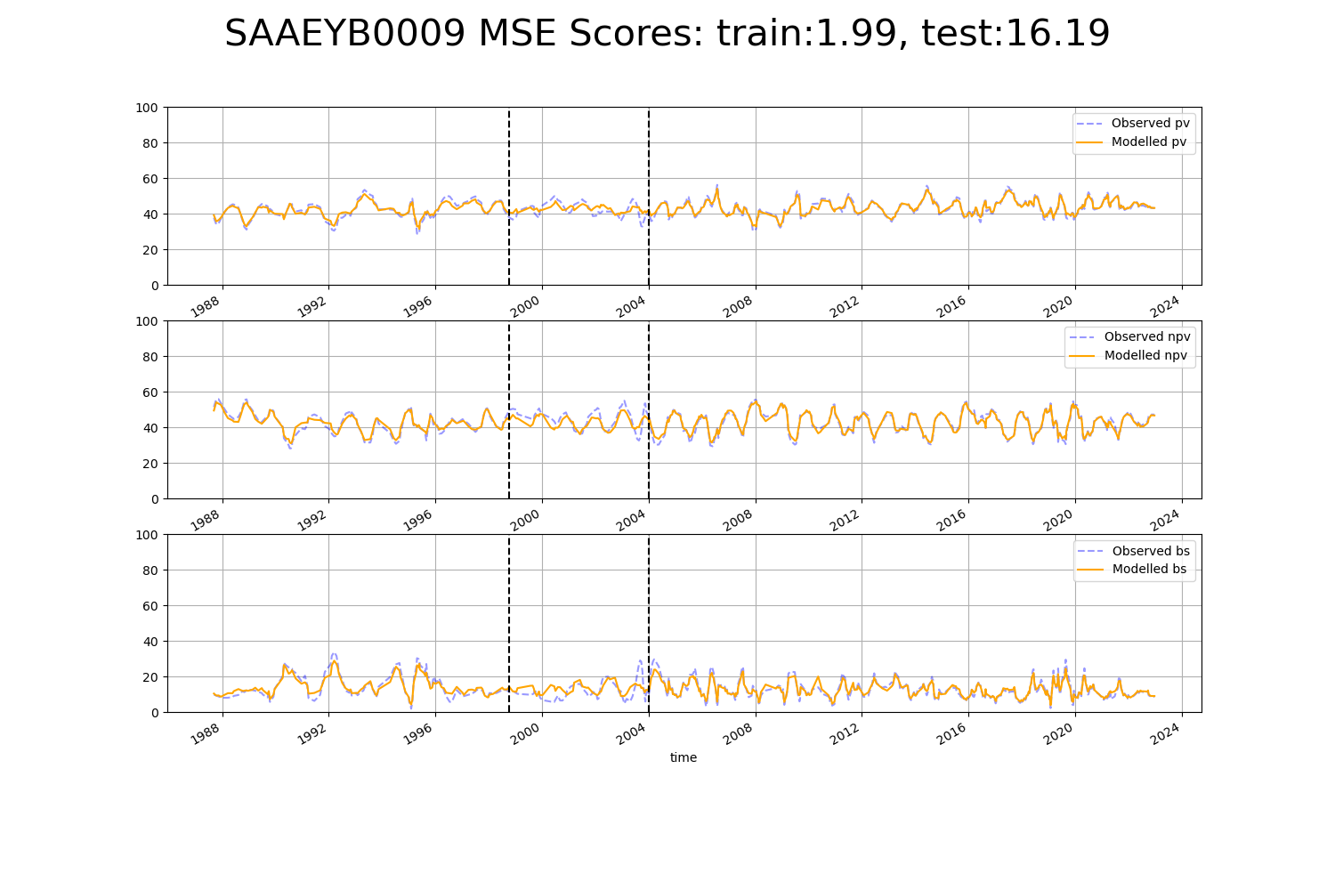

# SAAEYB0010

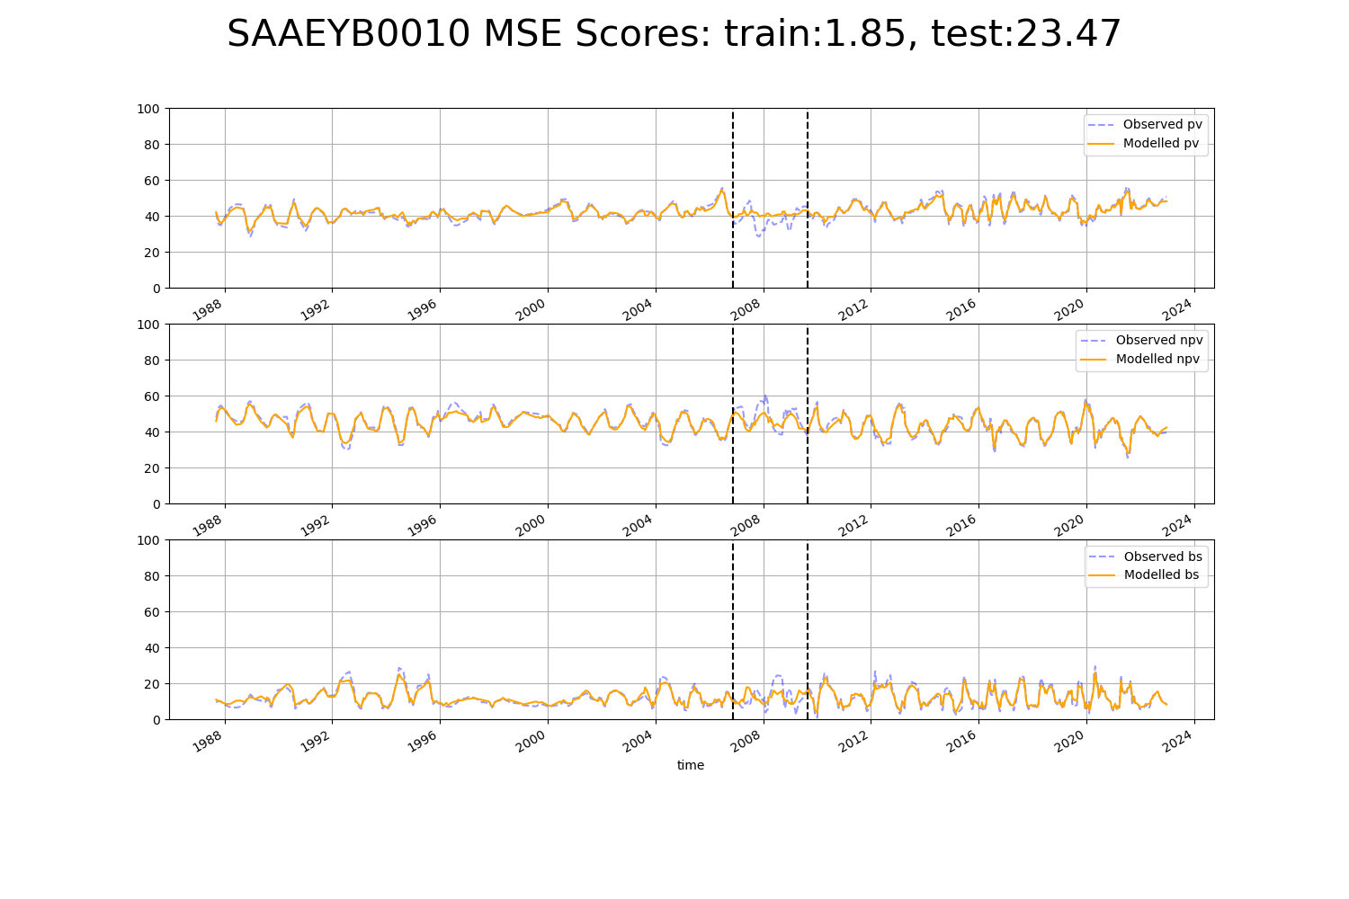

# SAAEYB0011

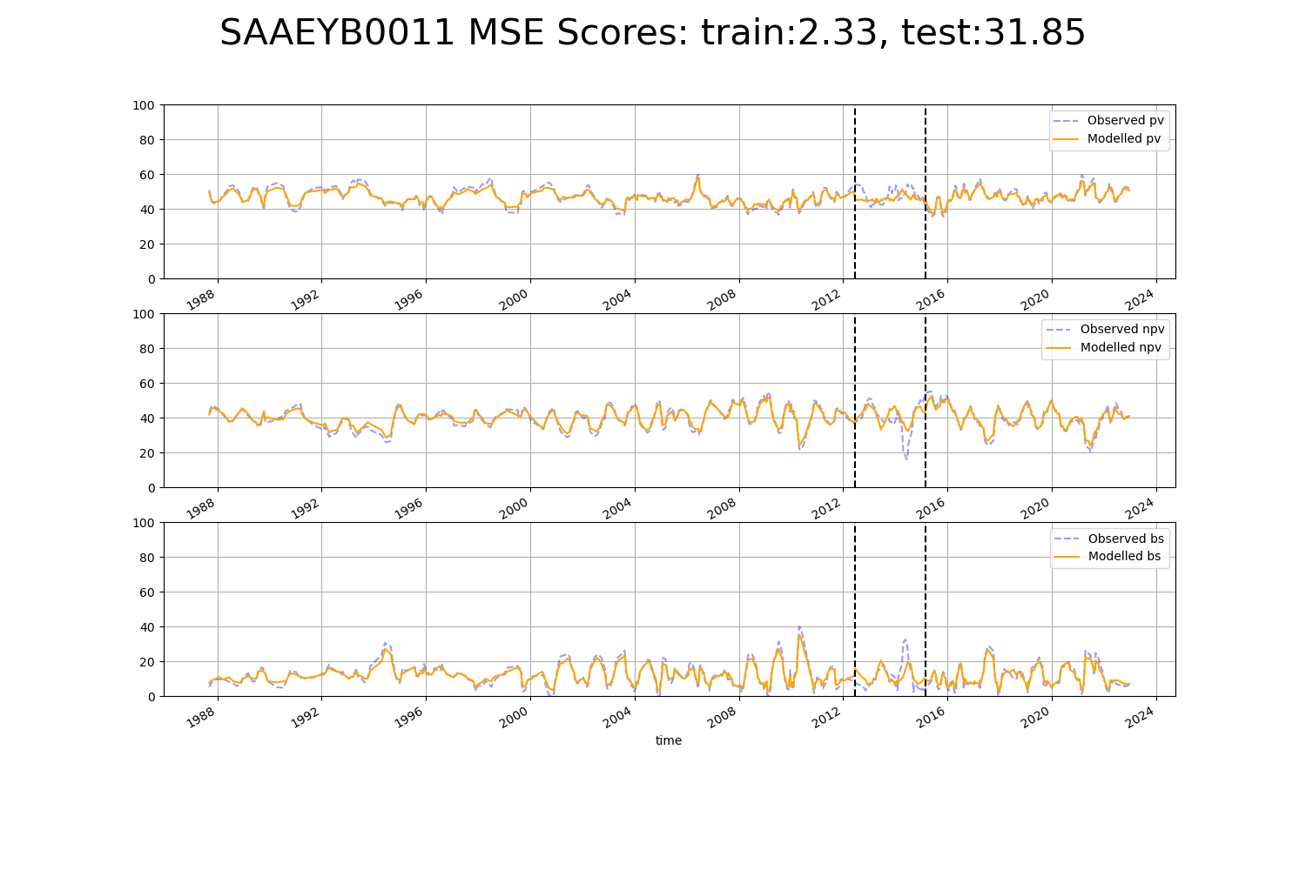

# SAAEYB0012

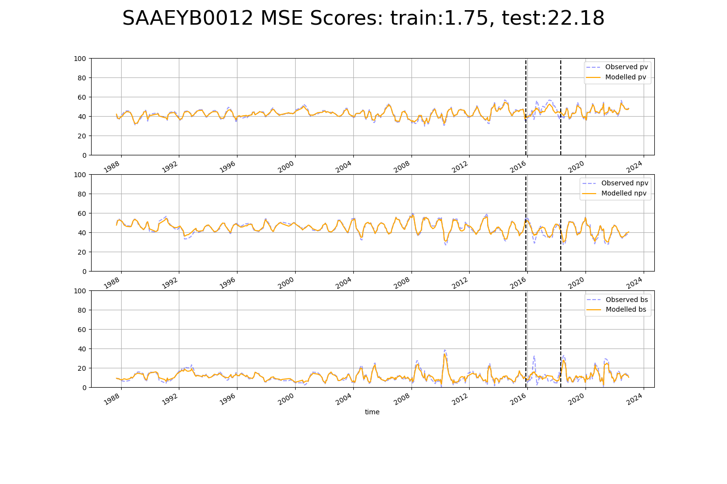

# SAAEYB0013

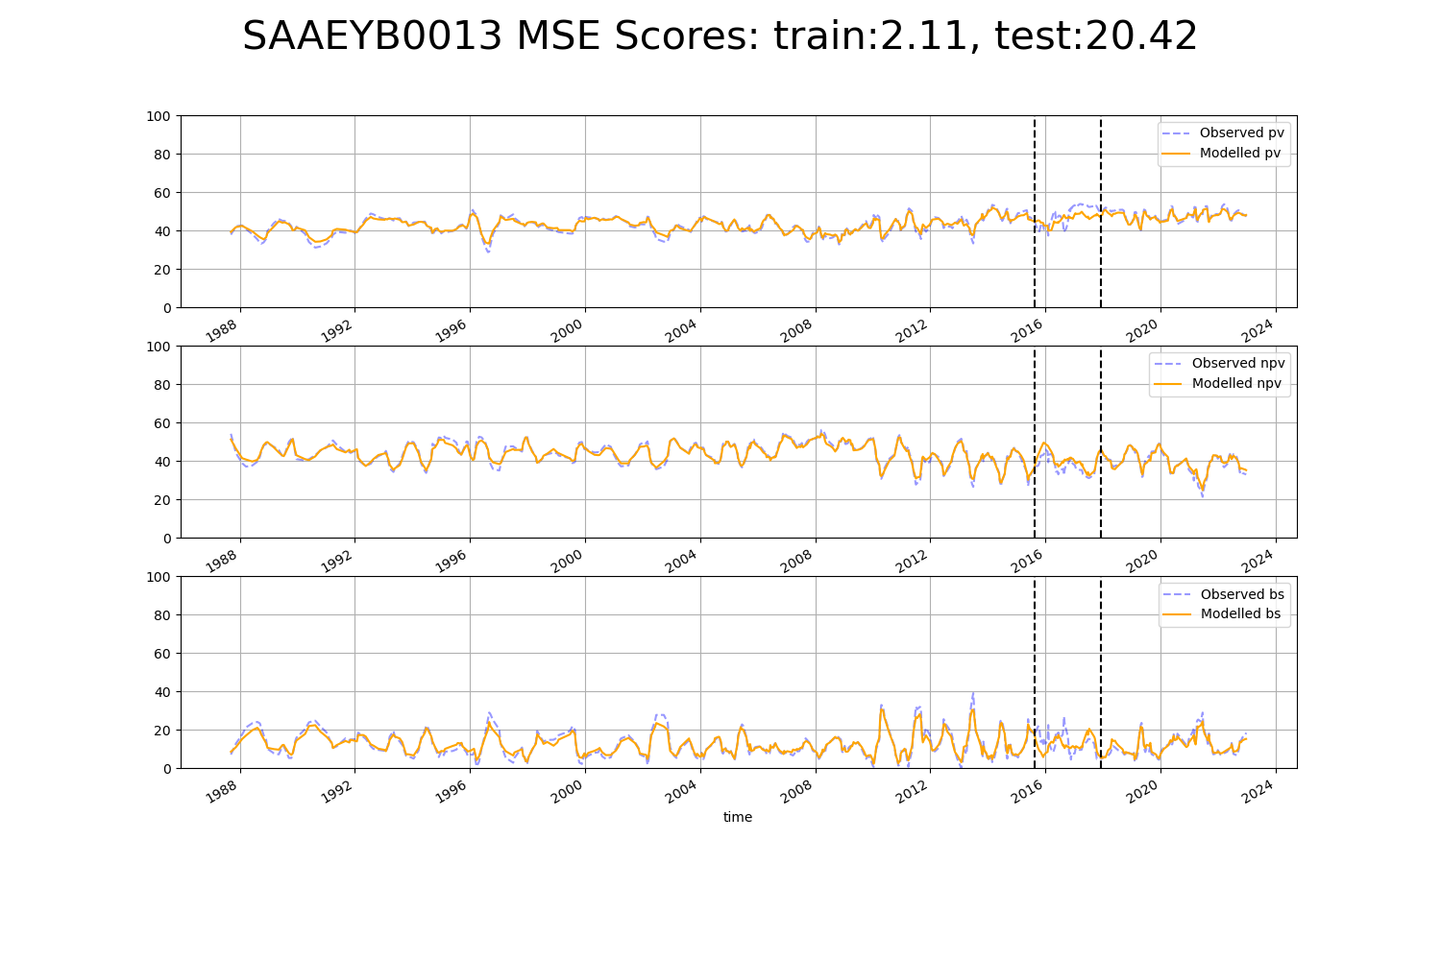

# SAAEYB0021

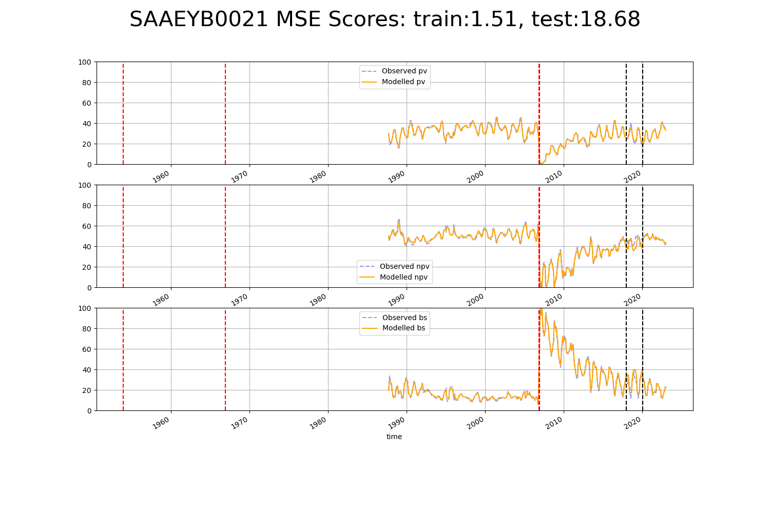

# SAAEYB0022

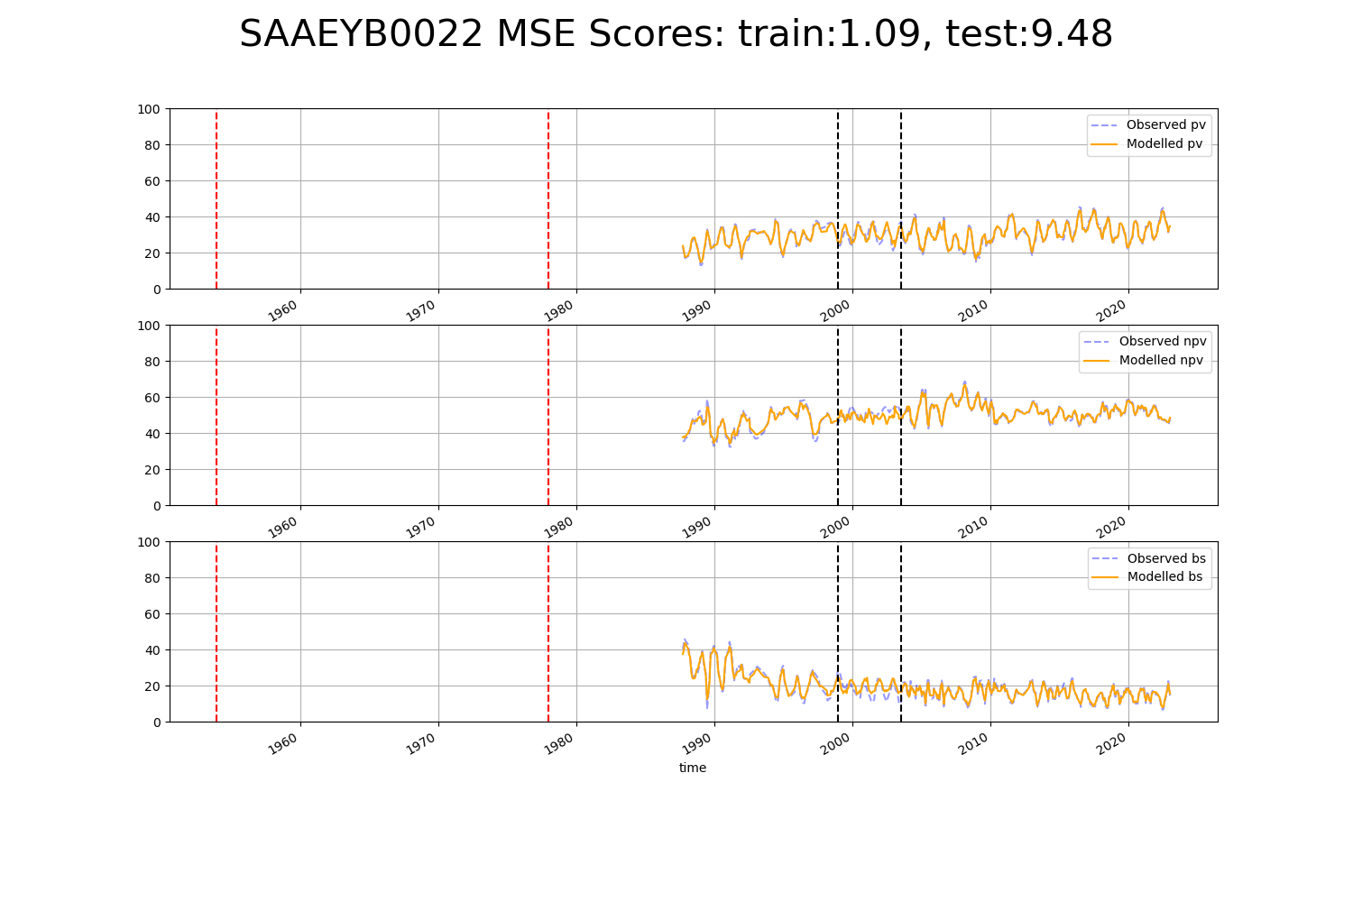

# SAAEYB0023

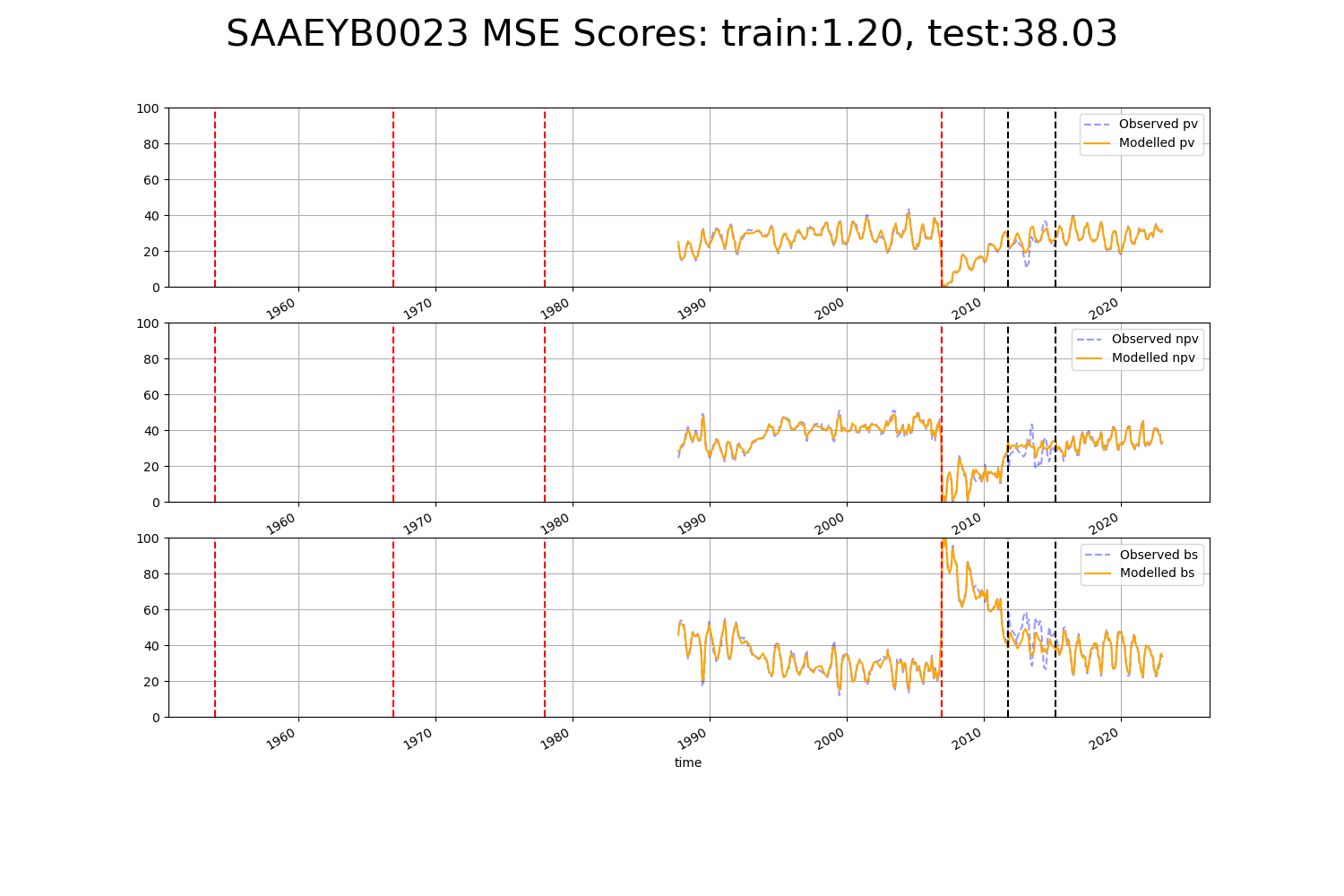

# SAAEYB0025

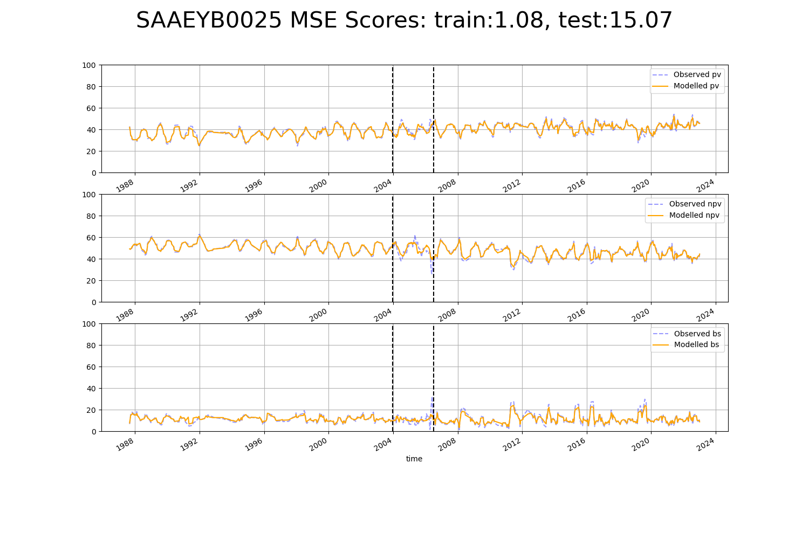

# SAAEYB0026

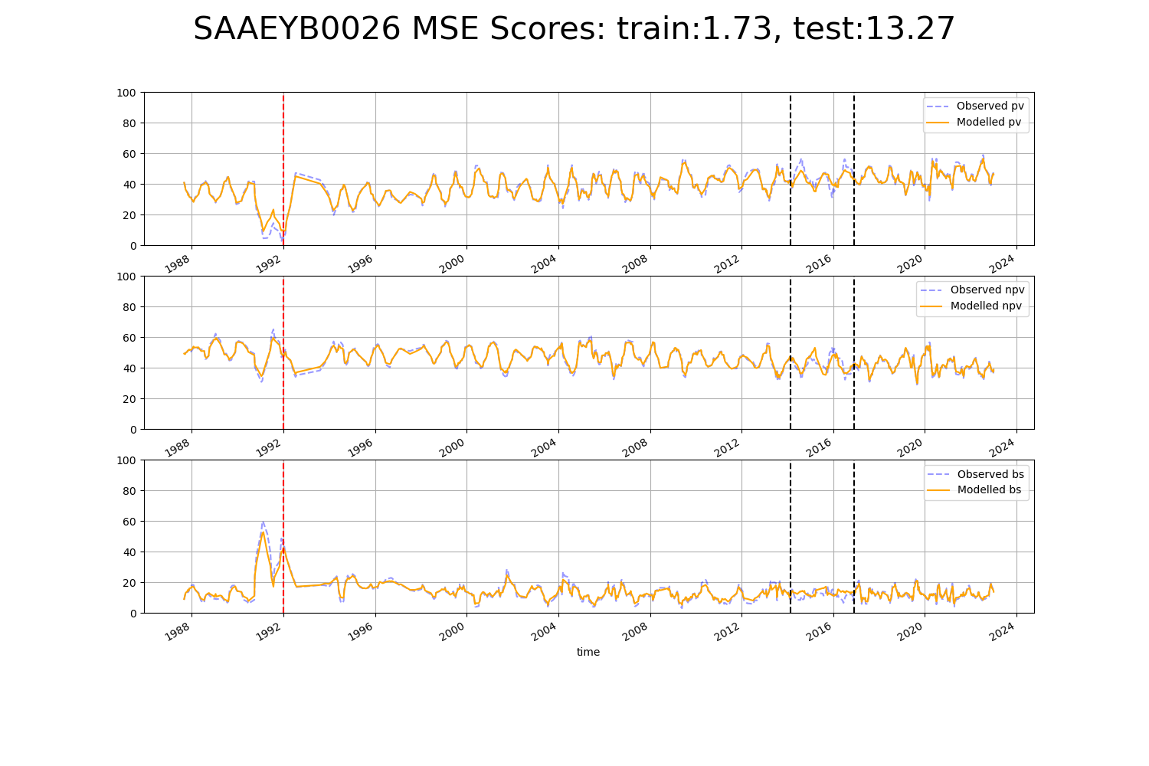

# SAAEYB0027

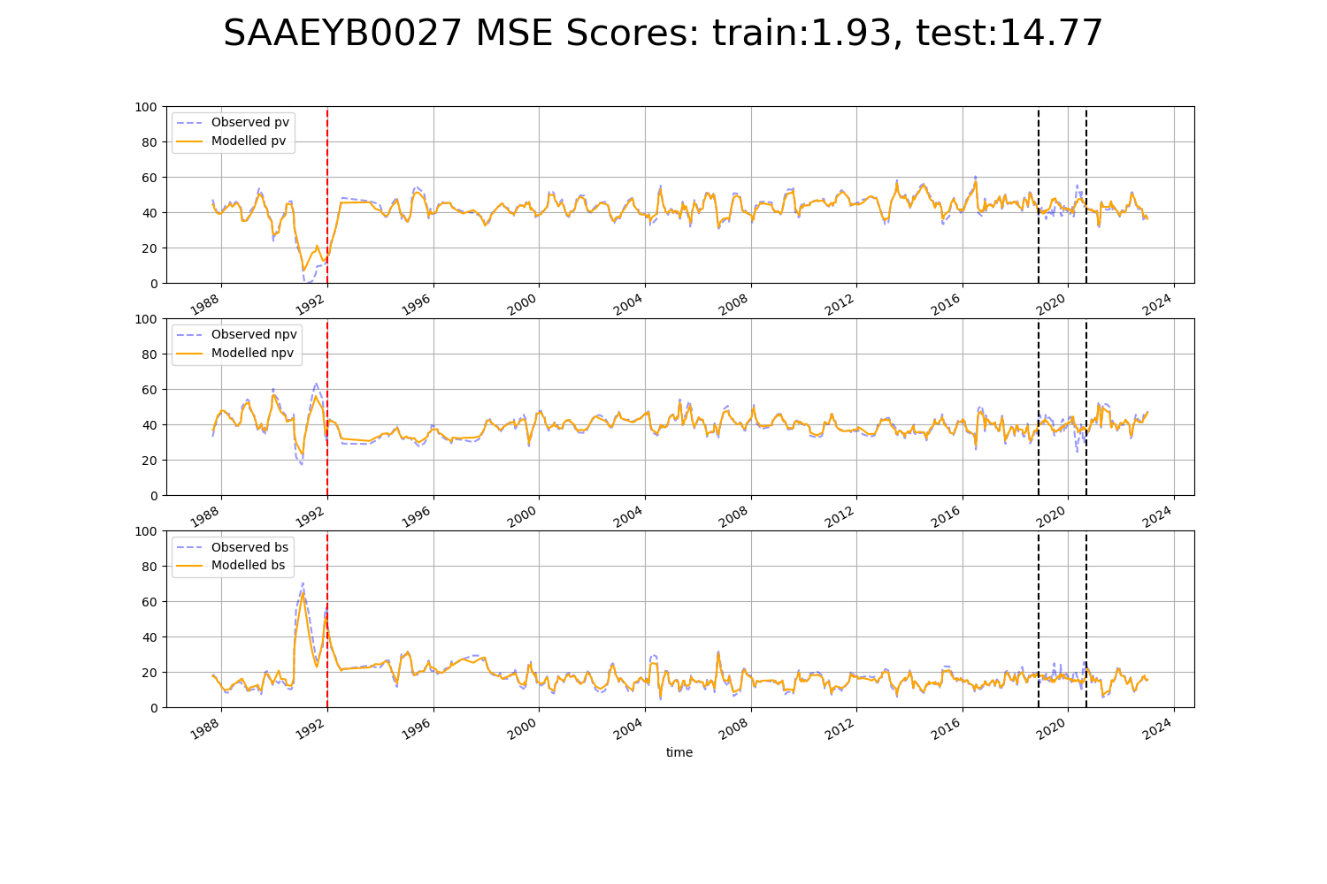

# SAAEYB0028

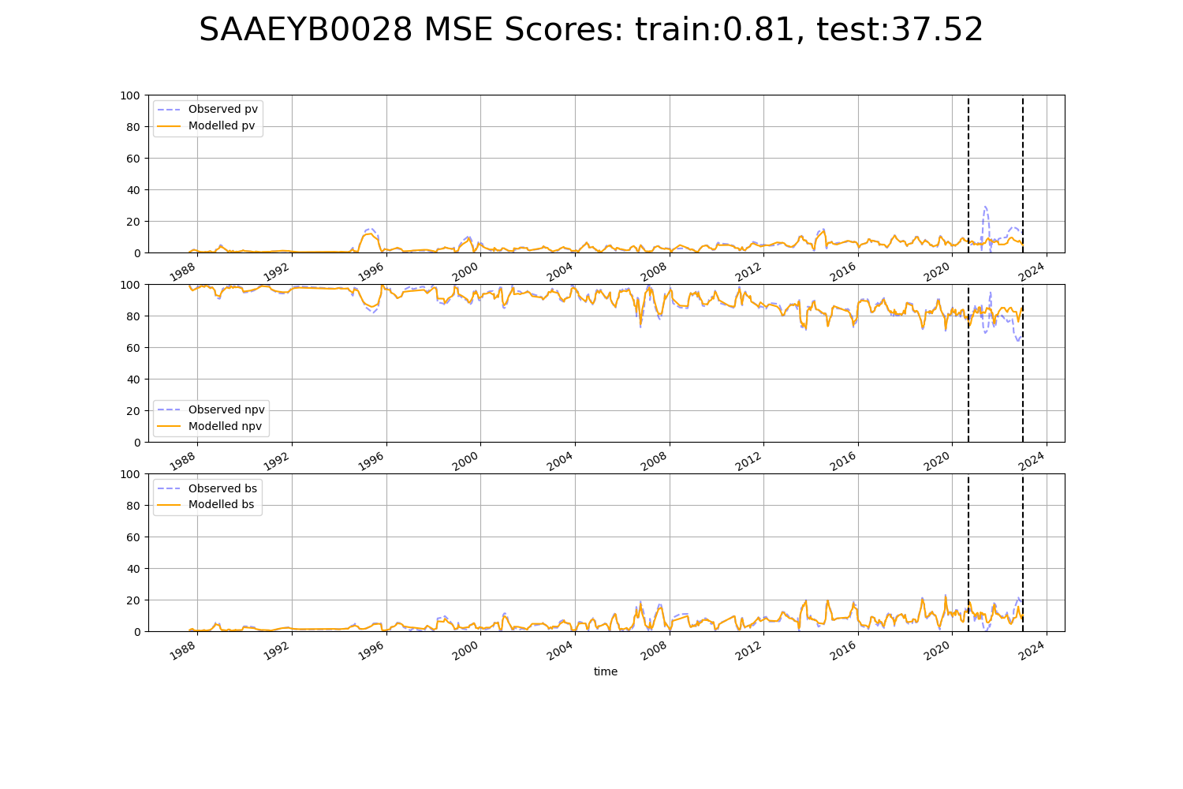

# SAAEYB0030

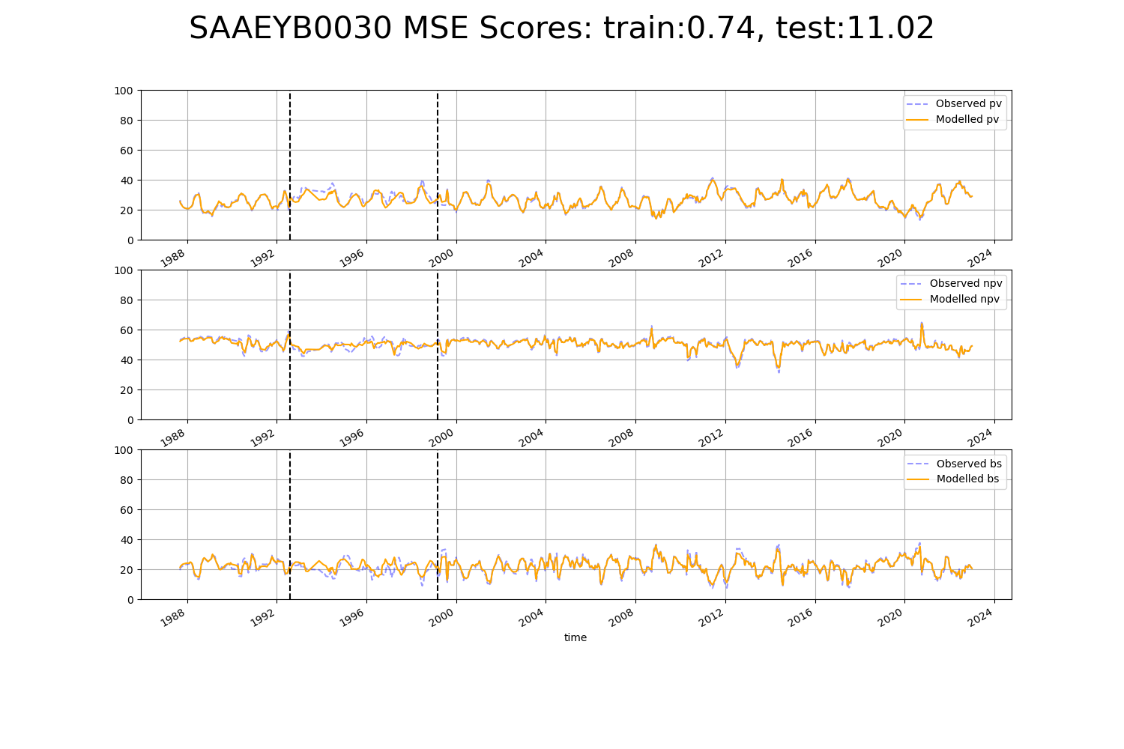

# SAAEYB0031

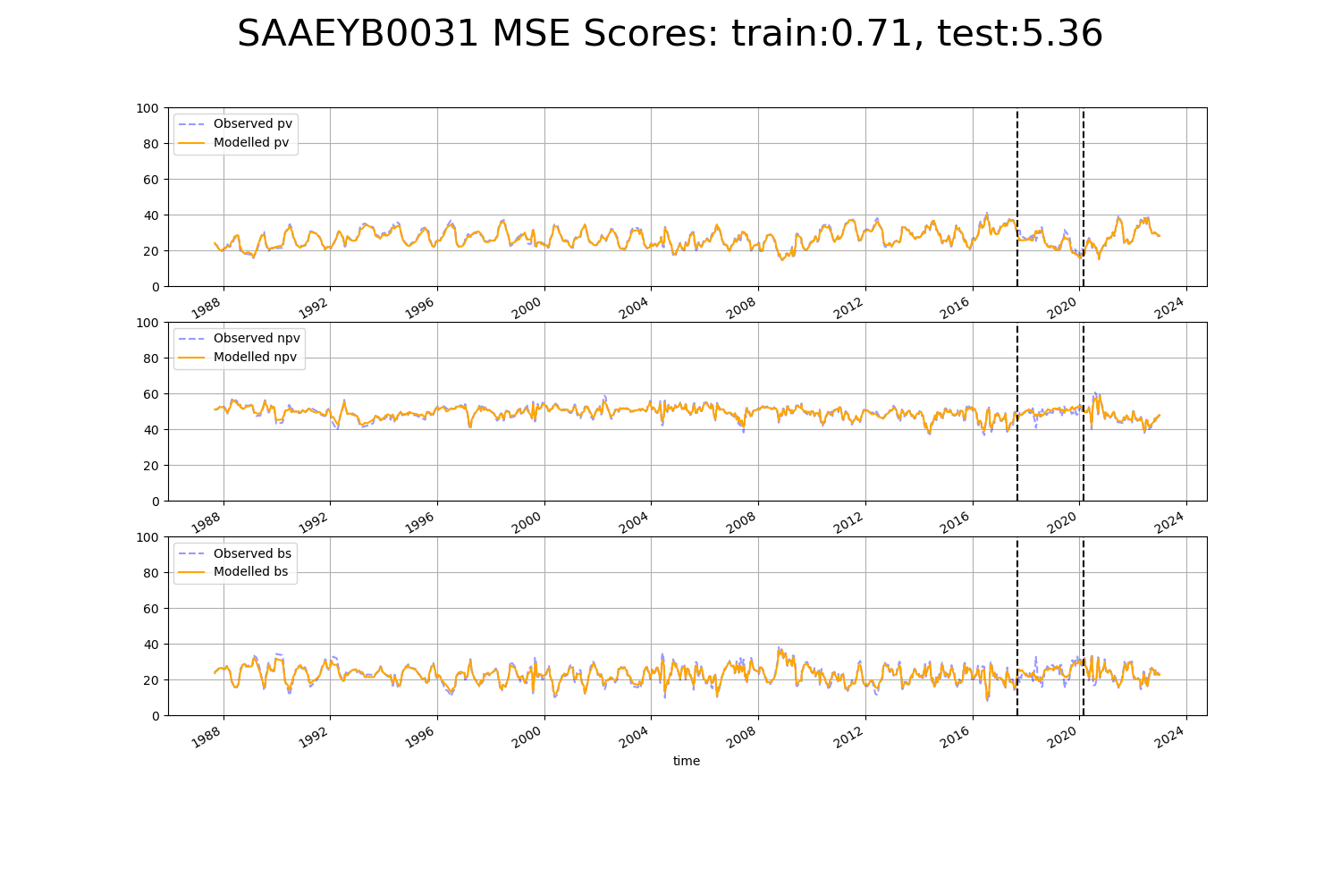

# SAAKAN0002

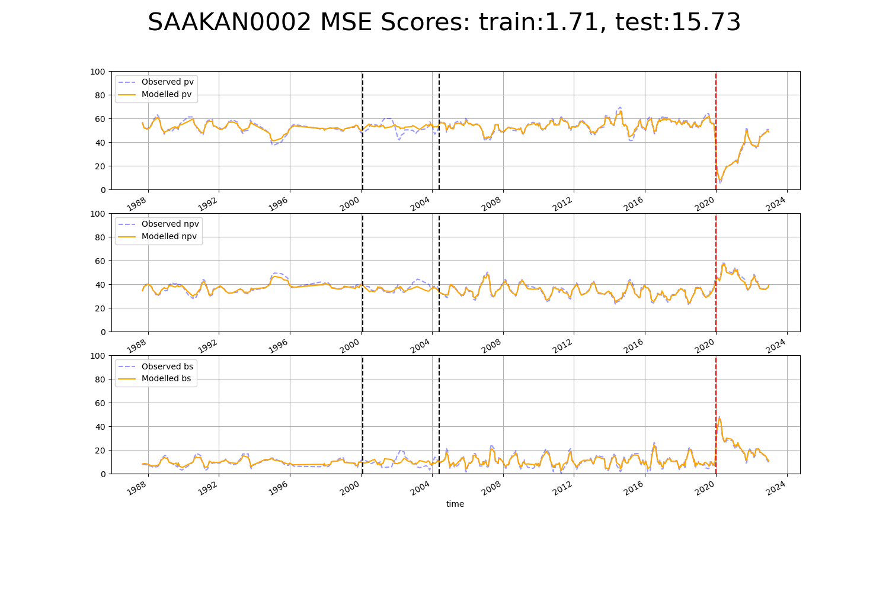

# SAAKAN0004

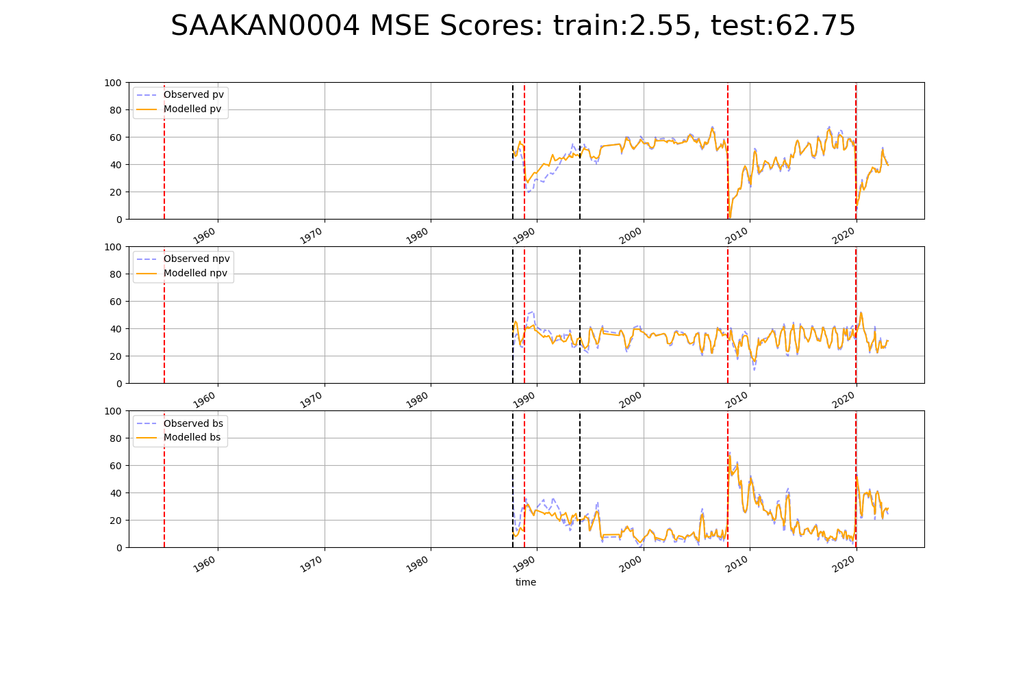

# SAAKAN0005

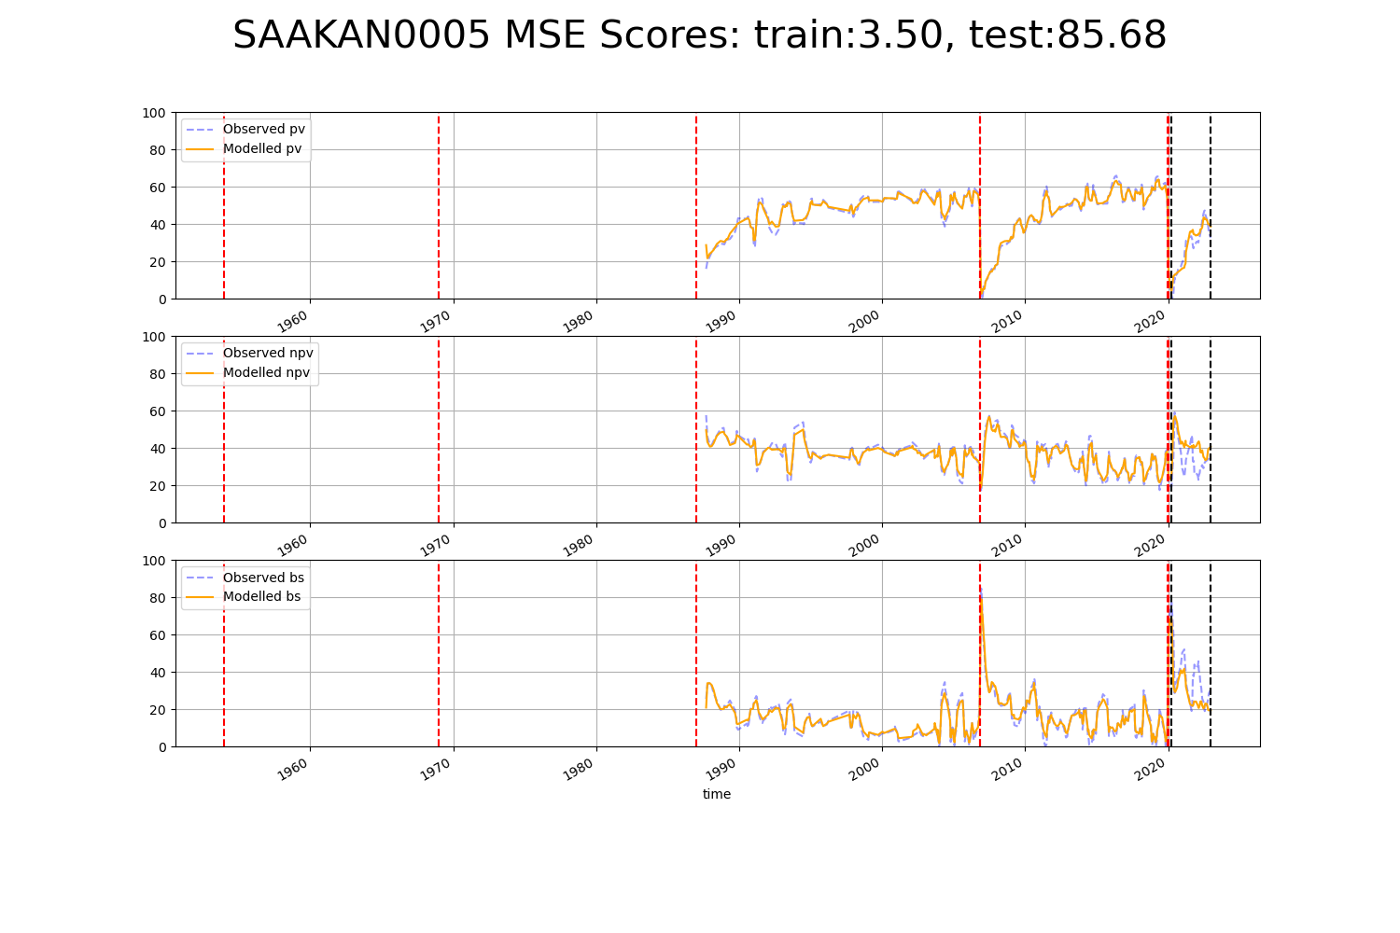

# SAAKAN0006

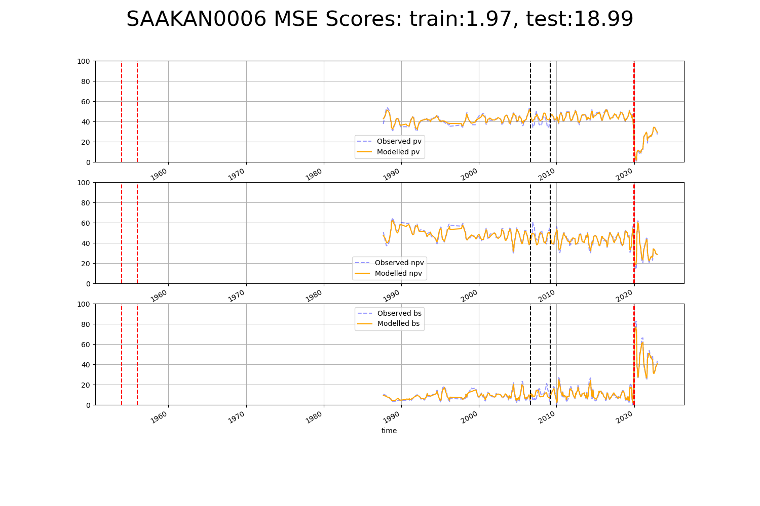

# SAAKAN0007

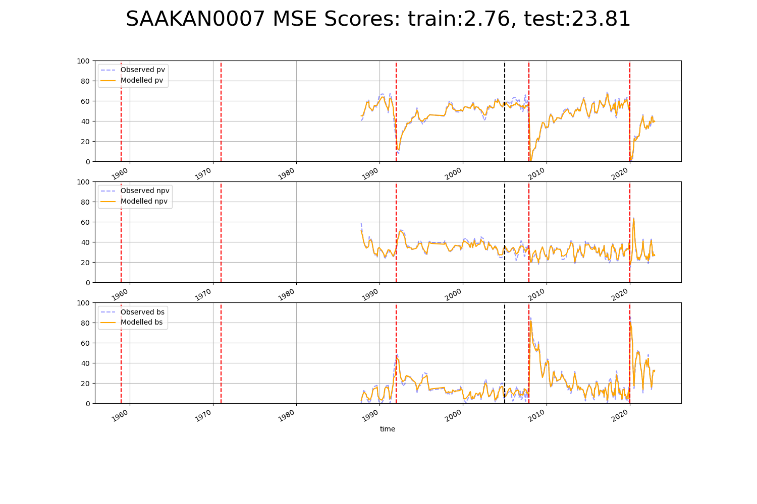

# SAAKAN0008

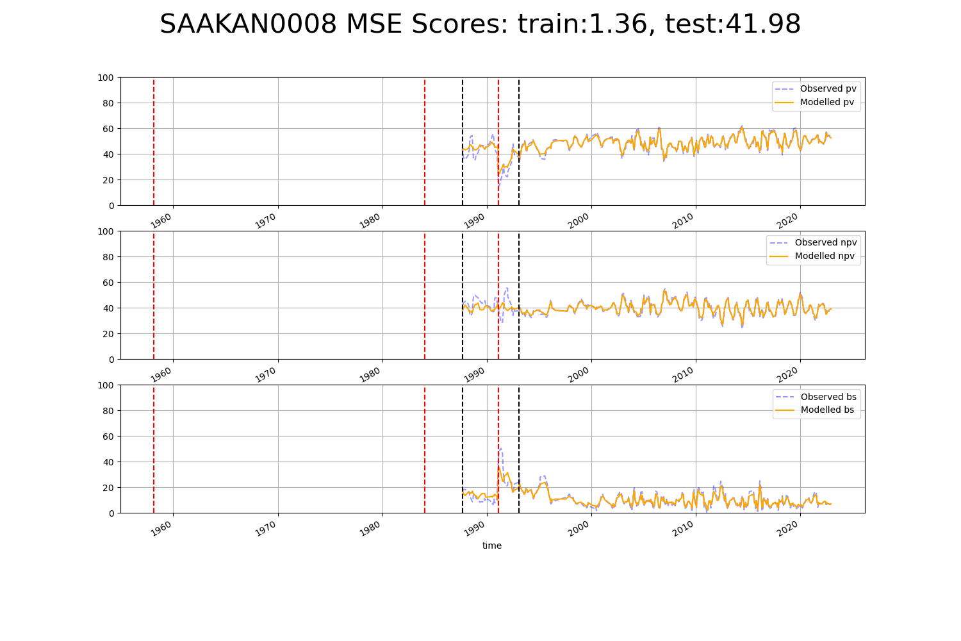

# SAAKAN0009

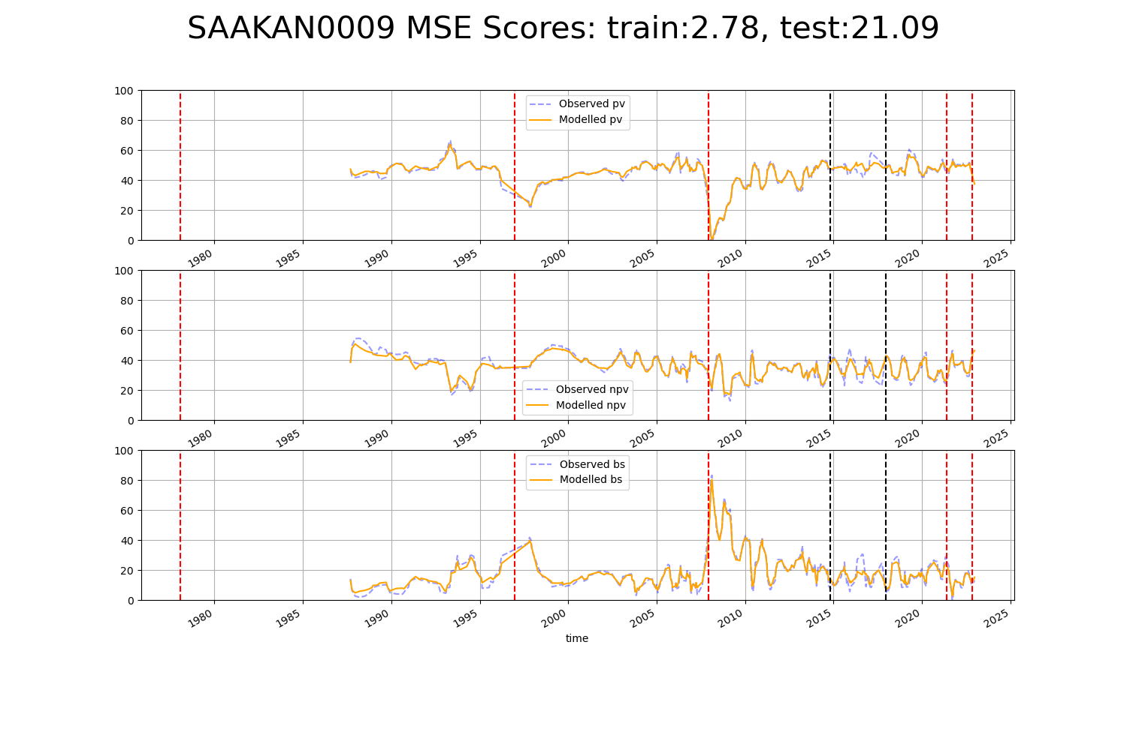

# SAAKAN0010

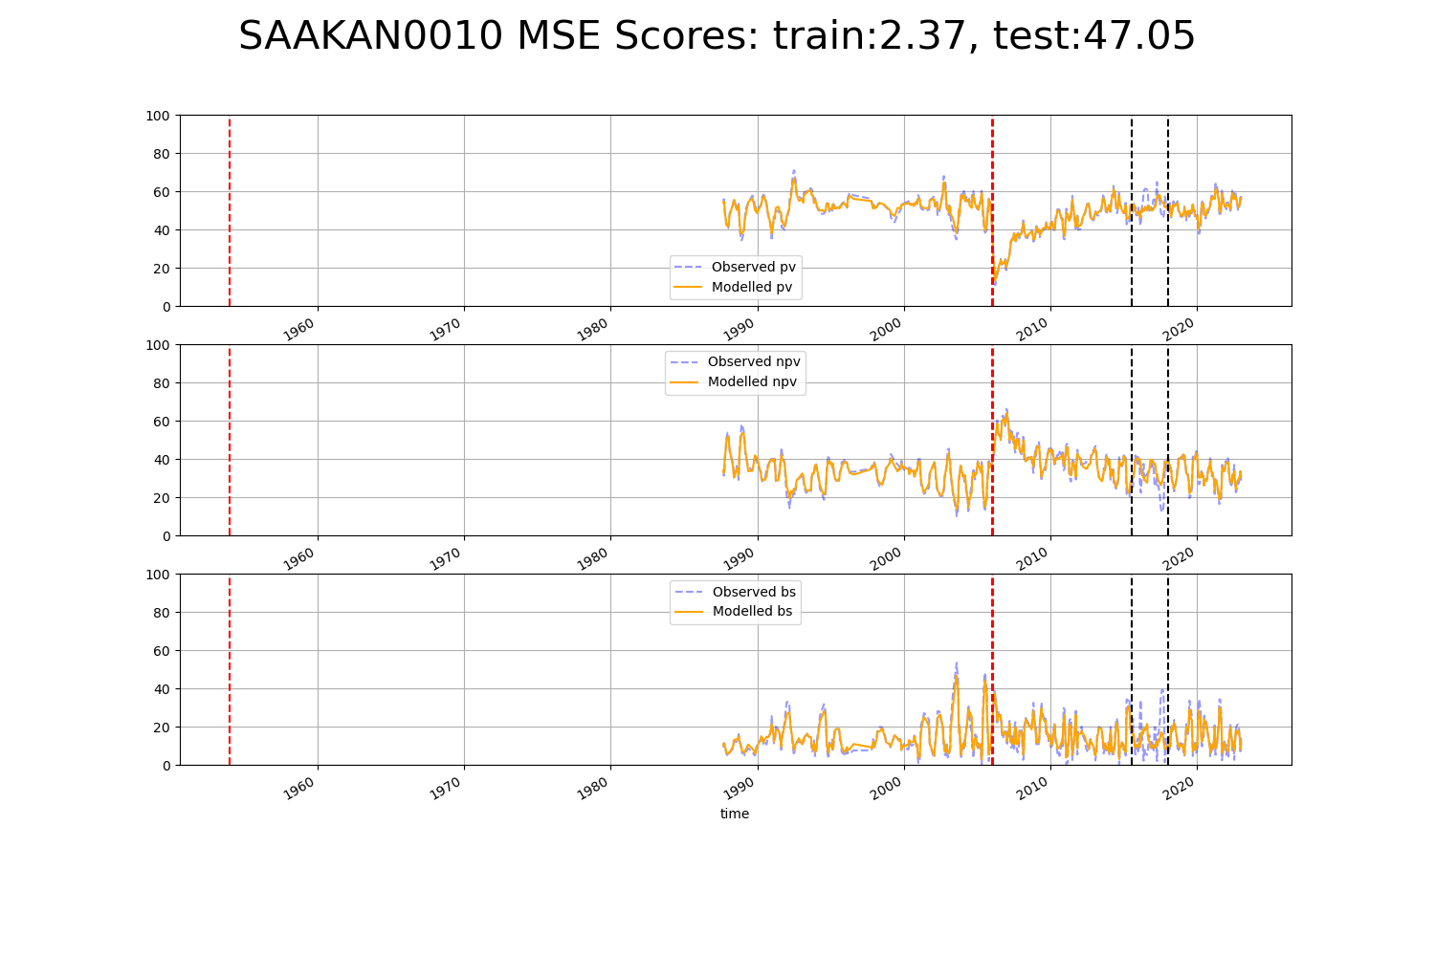

# SAAKAN0012

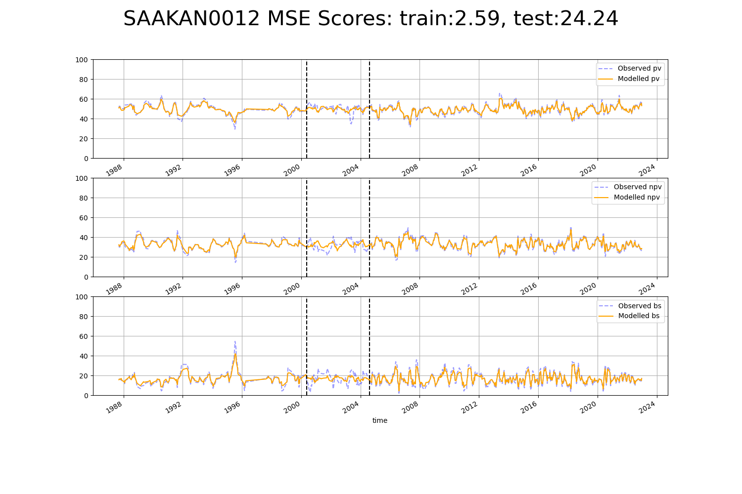

# SAAMDD0011

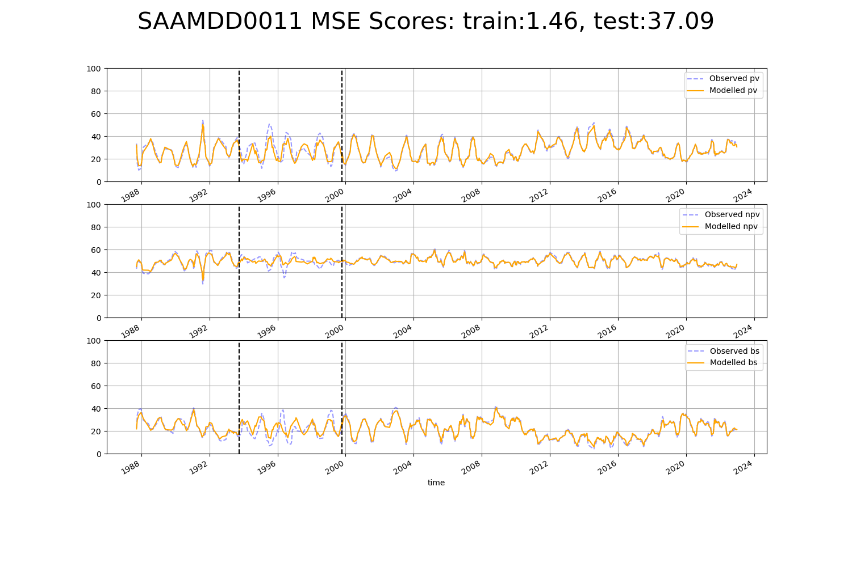

# SATFLB0002

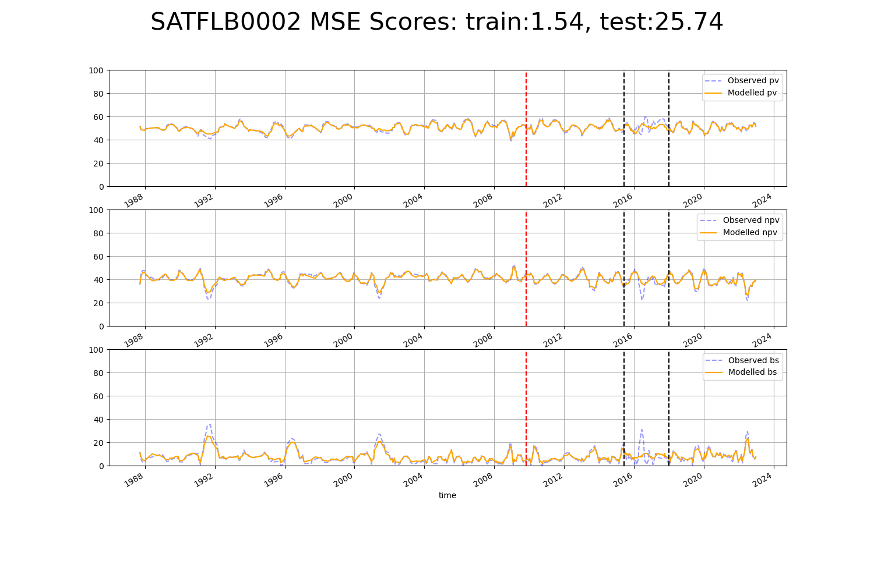

# TCABEL0002

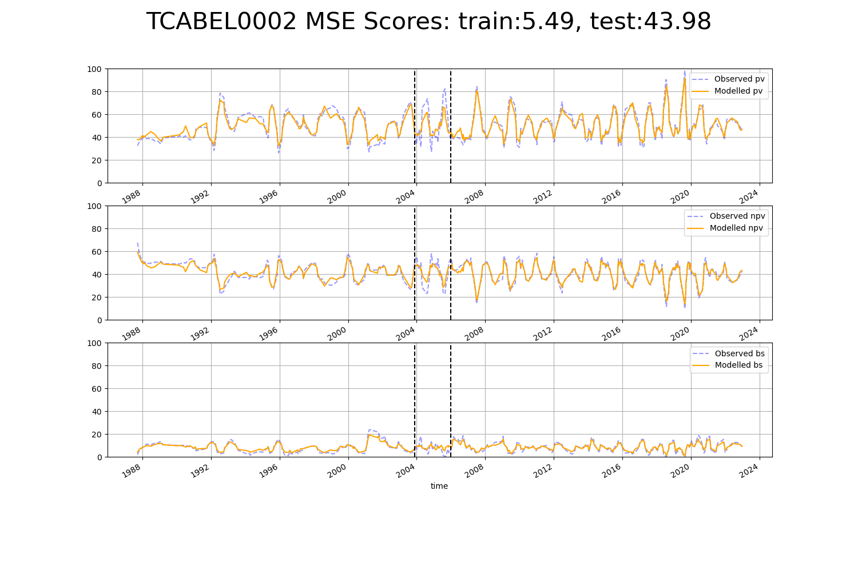

# TCATCH0001

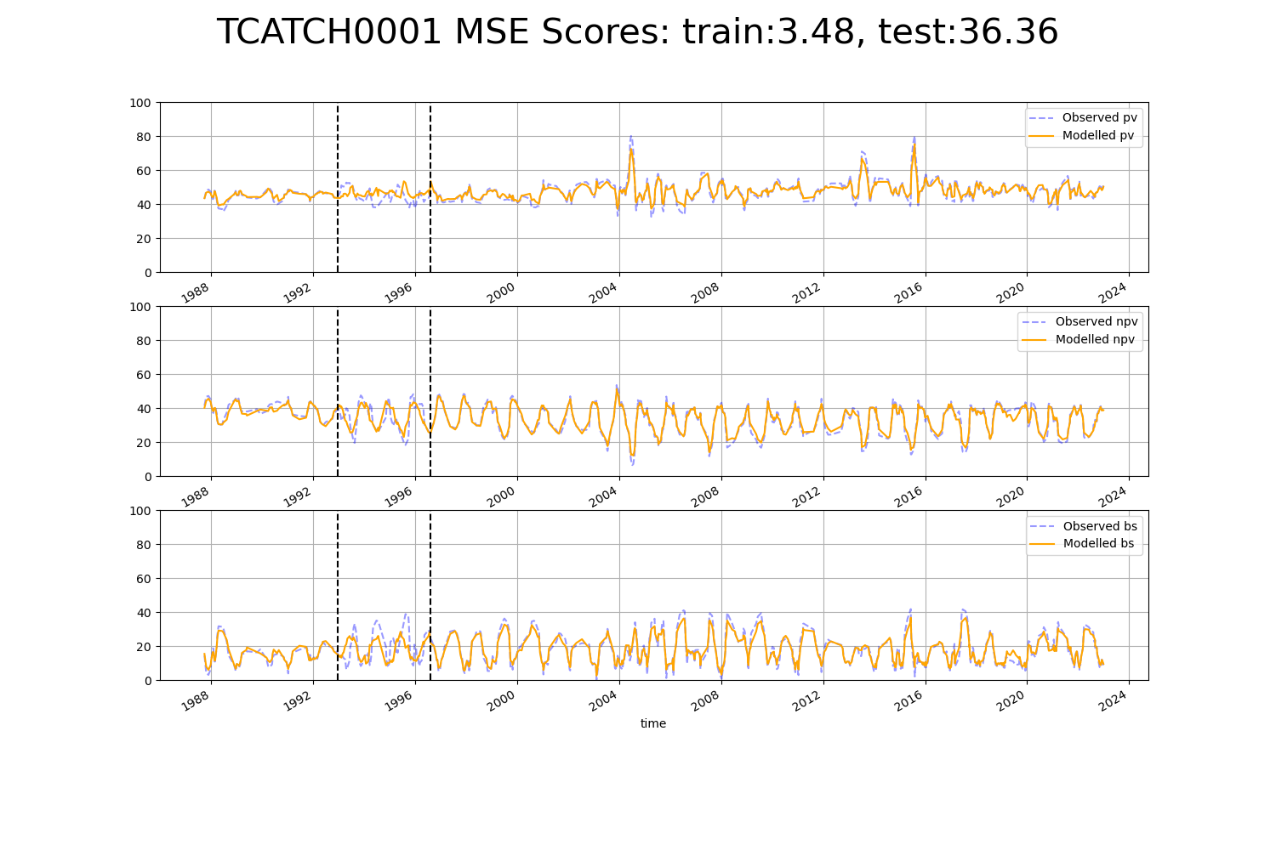

# TCATCH0007

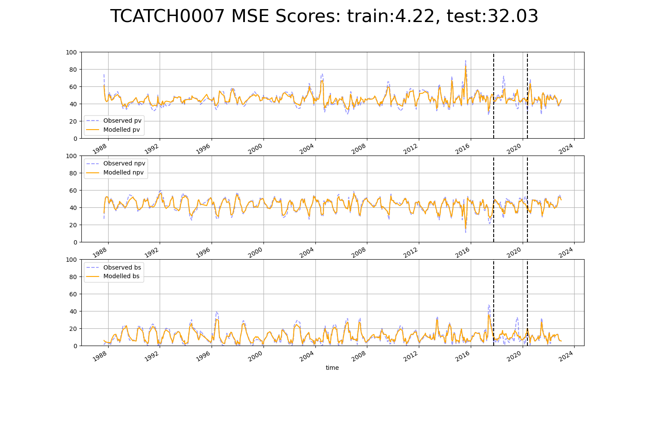

# VCAAUA0004

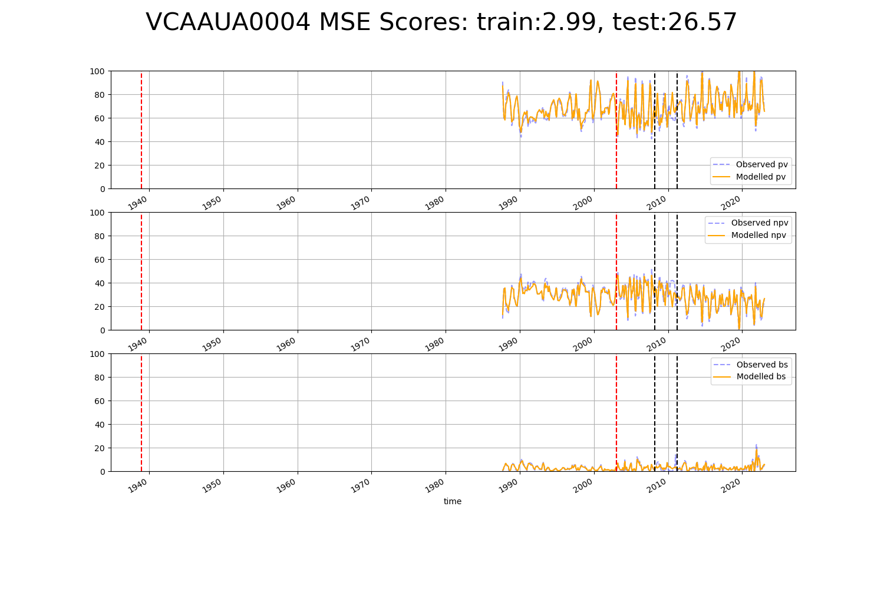

# VCAAUA0008

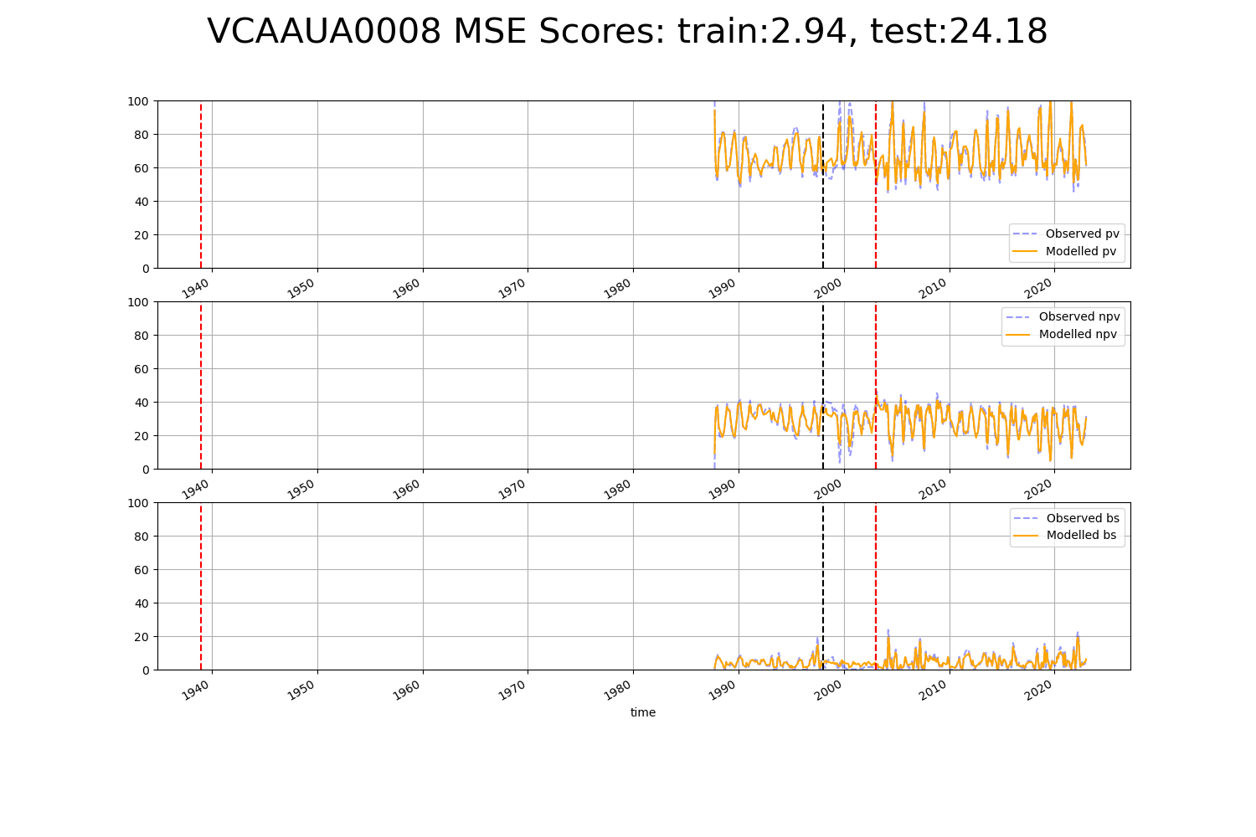

# VCAAUA0009

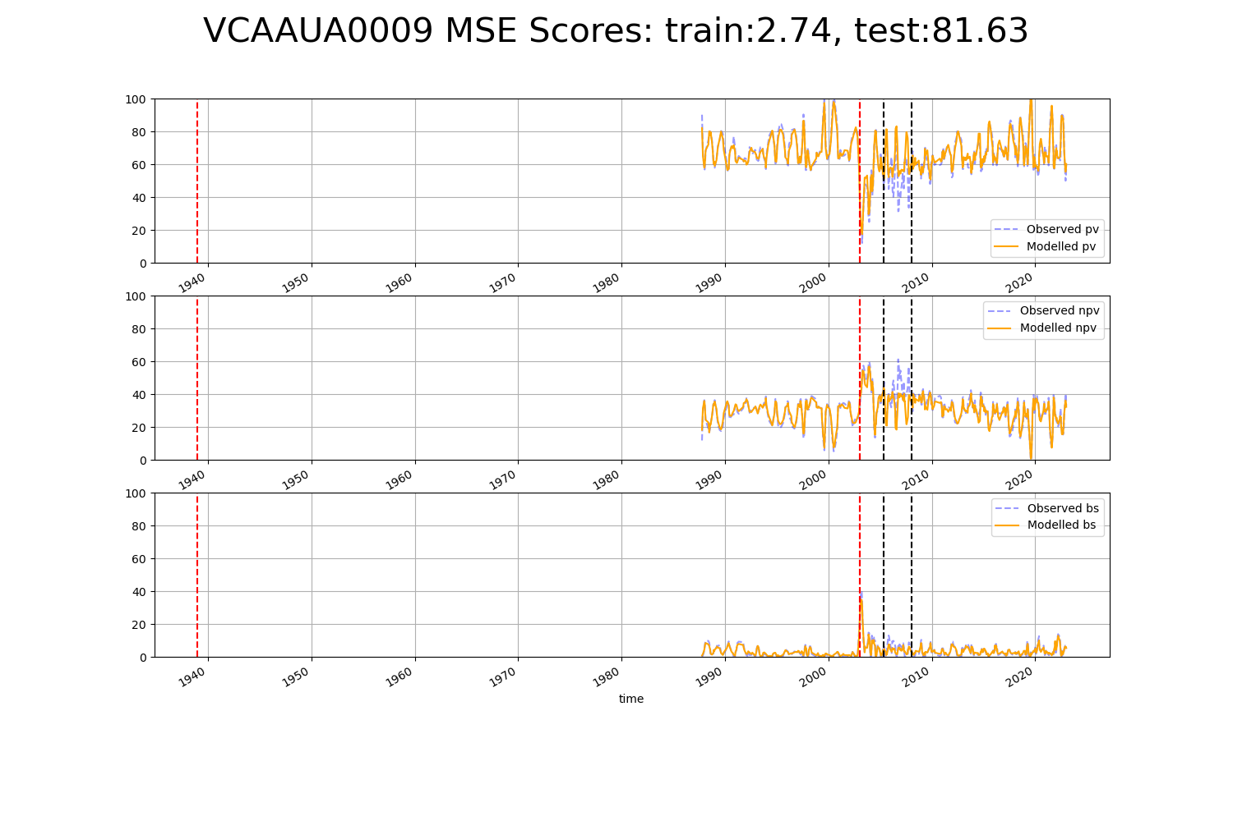

# WAAAVW0001

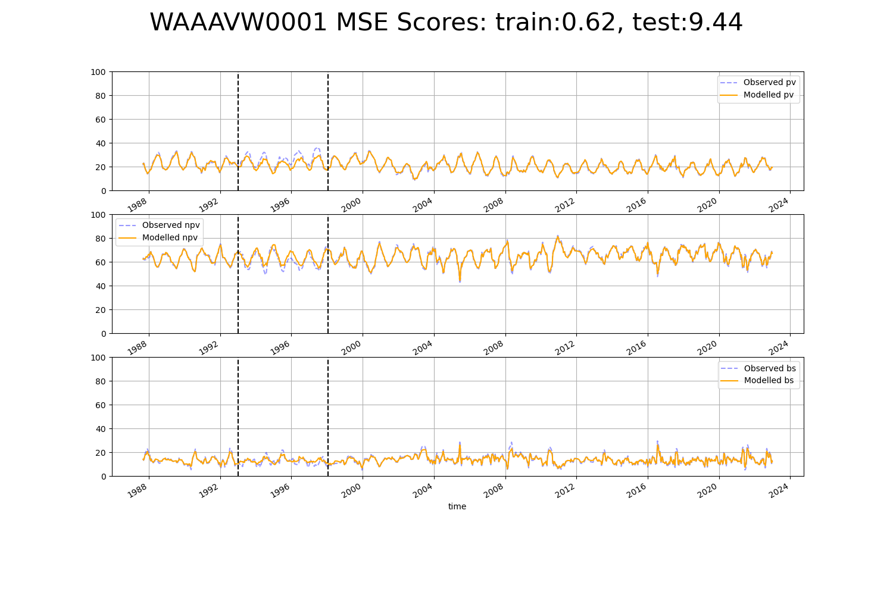

# WAAAVW0002

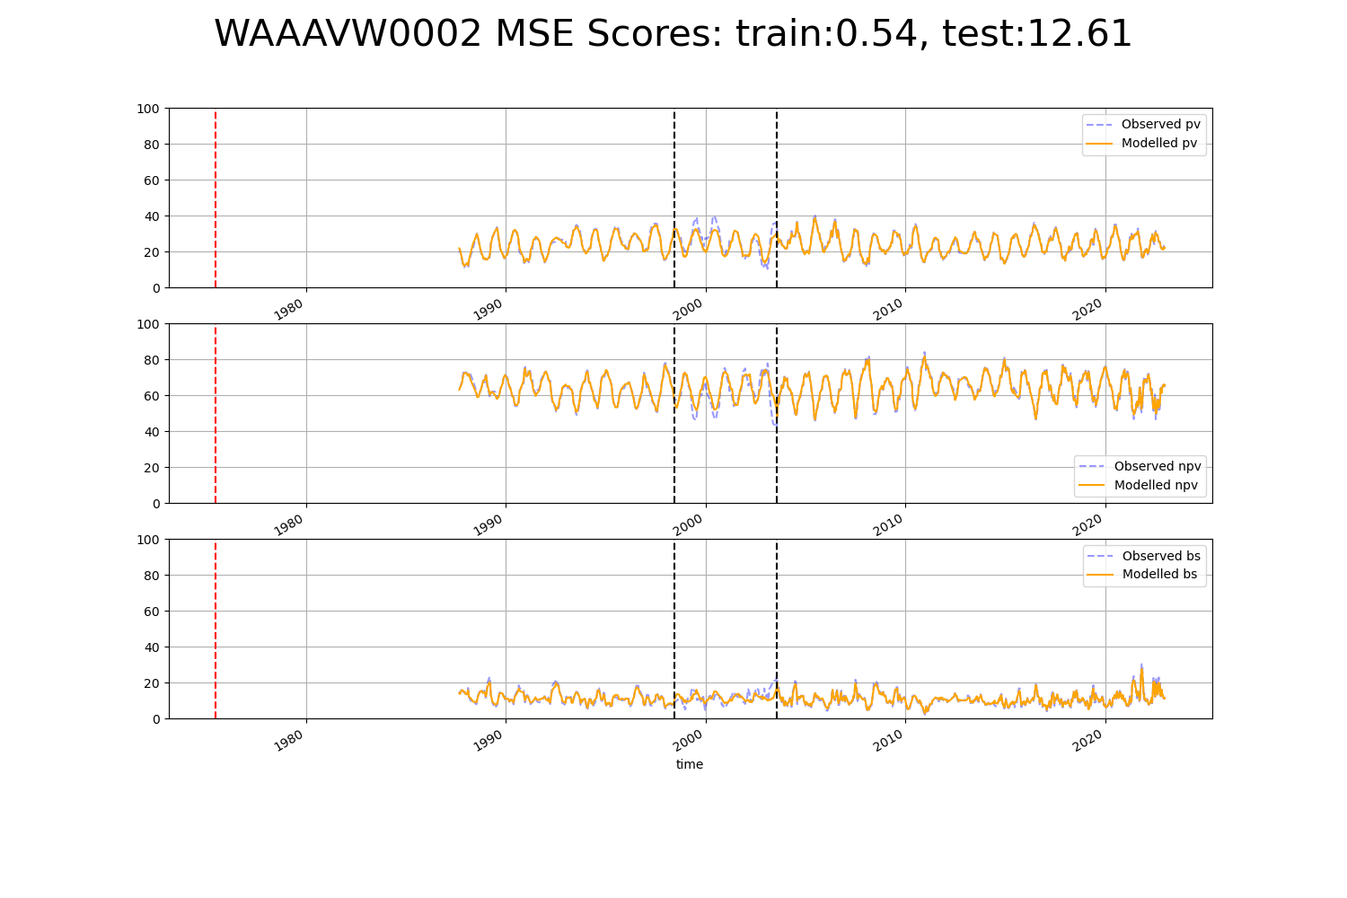

# WAAAVW0007

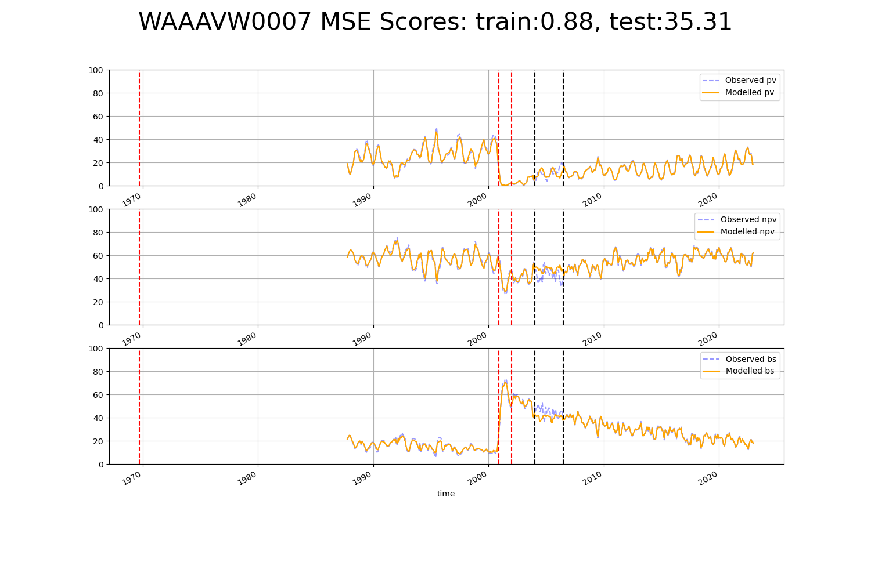

# WAACOO0001

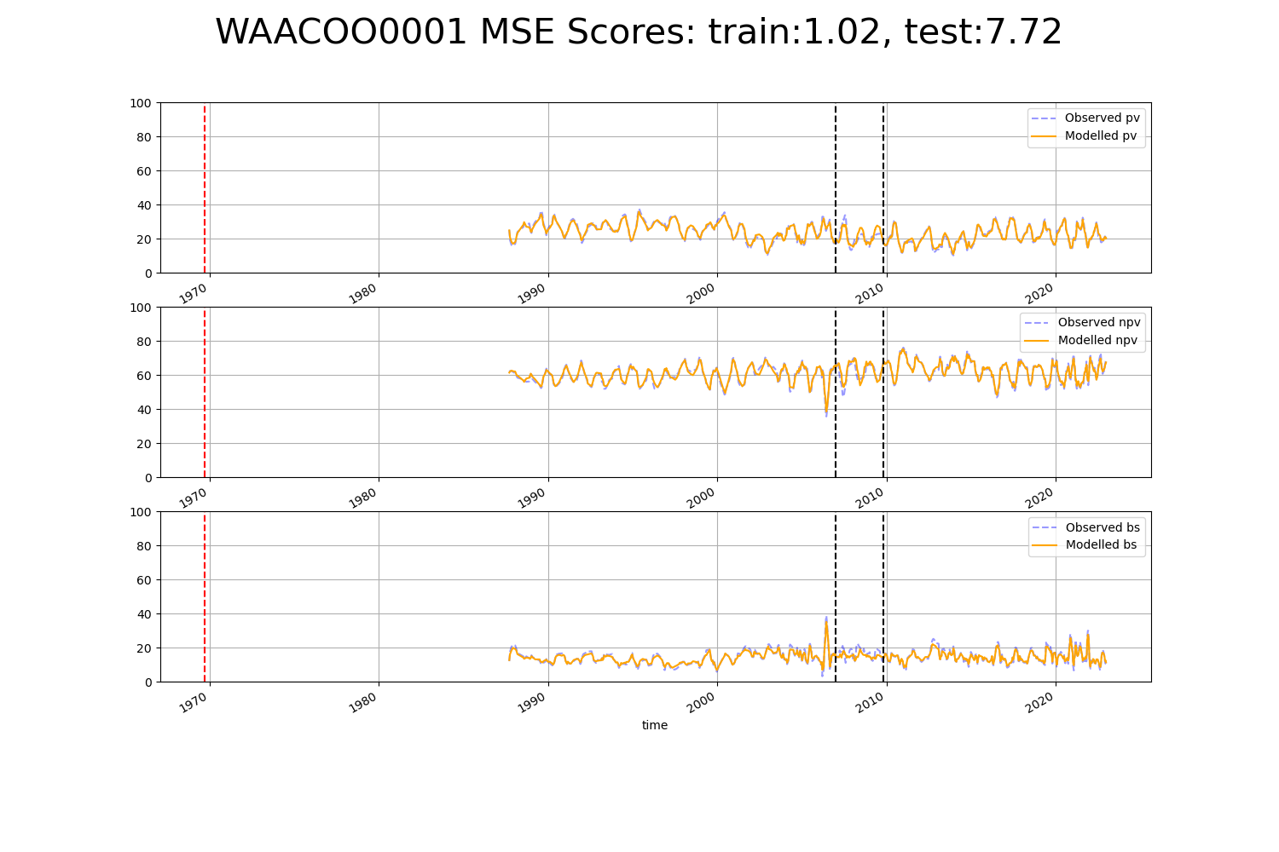

# WAACOO0003

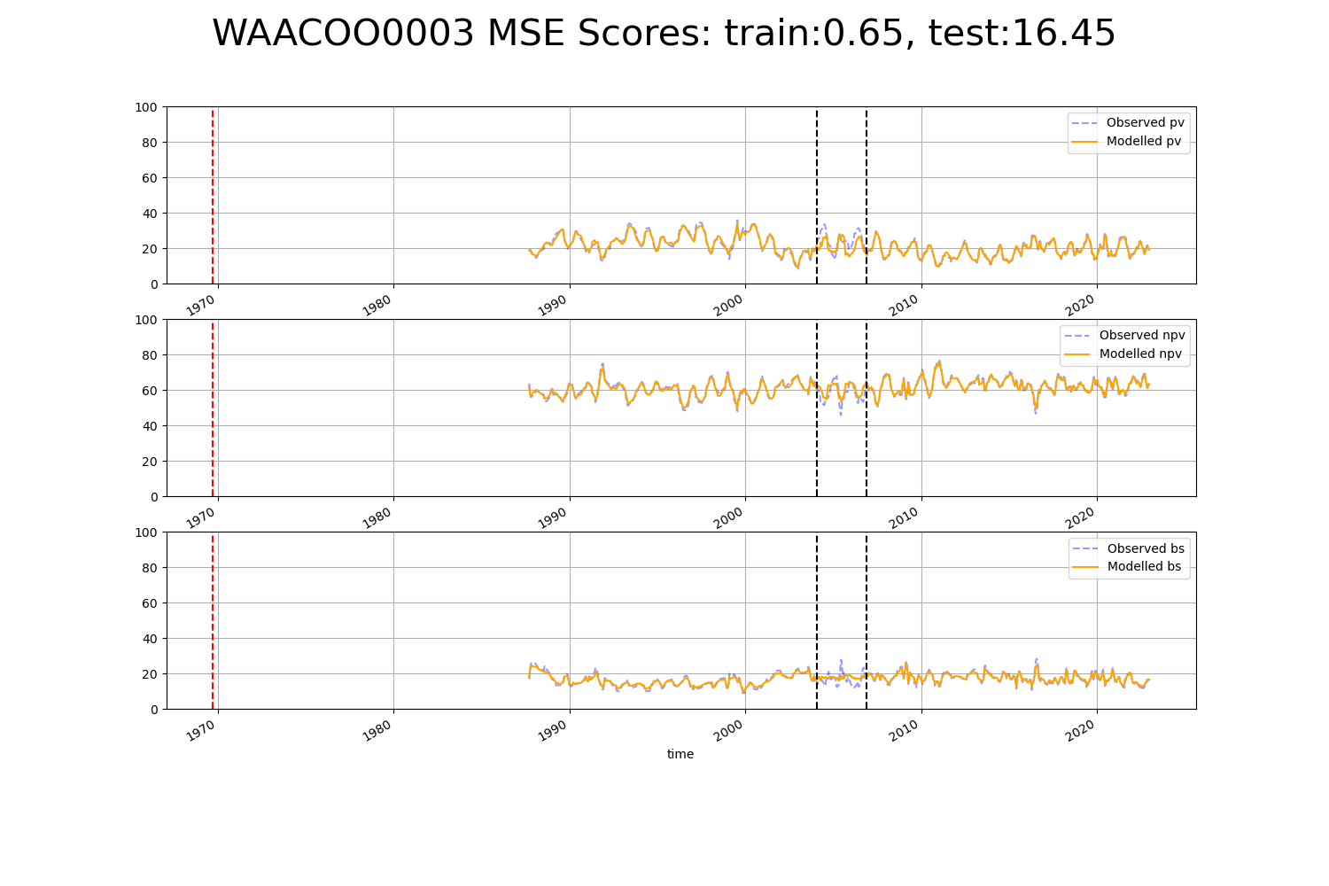

# WAACOO0004

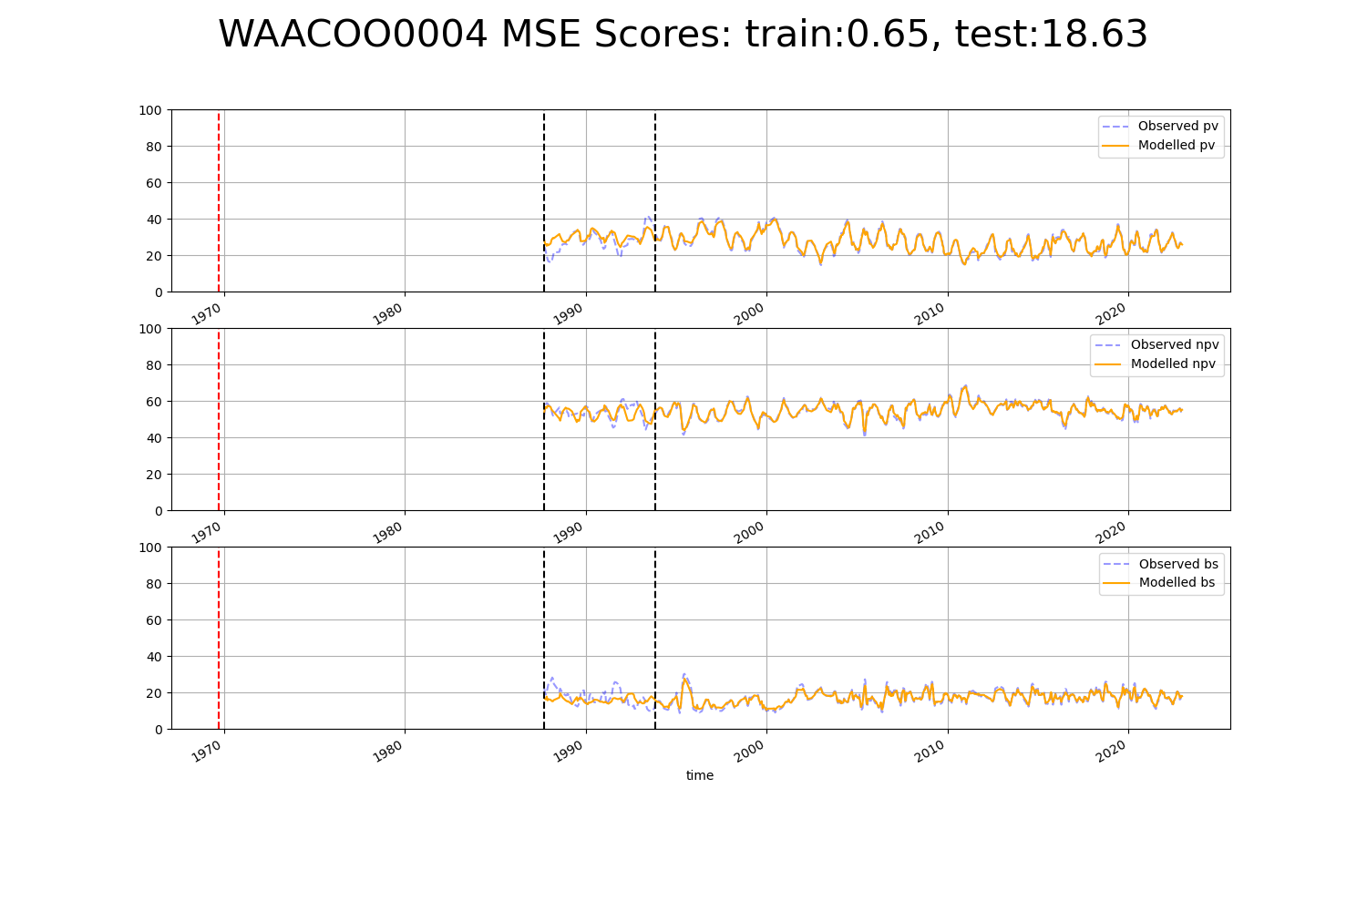

# WAACOO0006

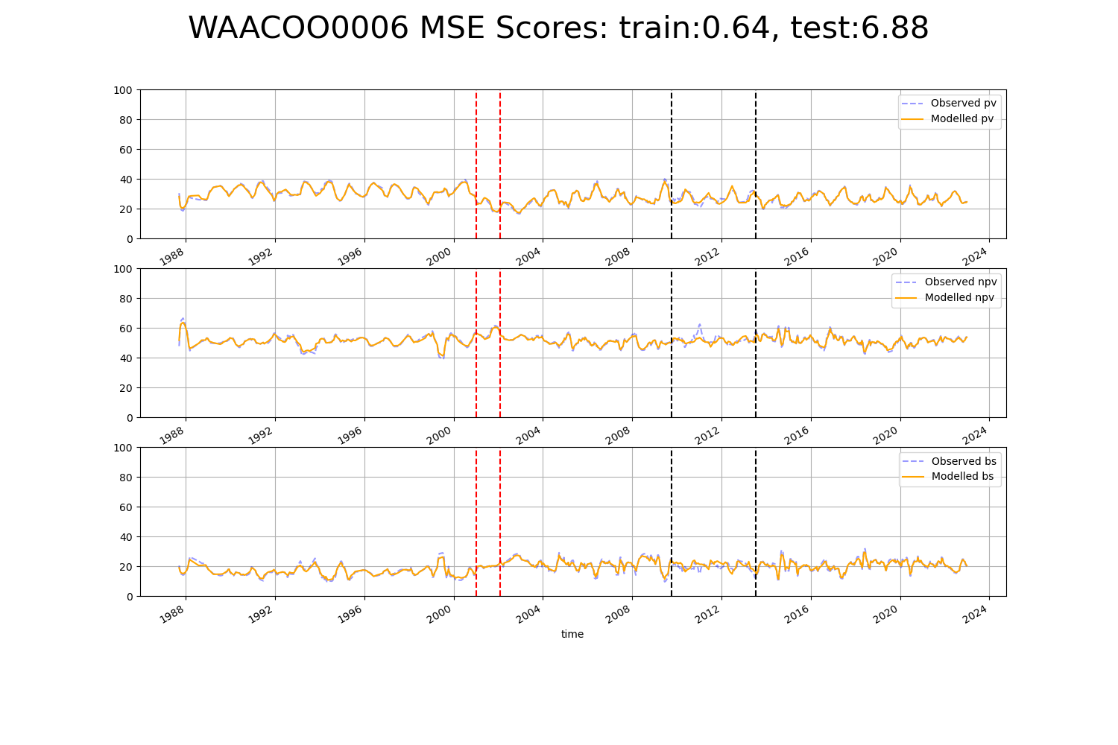

# WAACOO0007

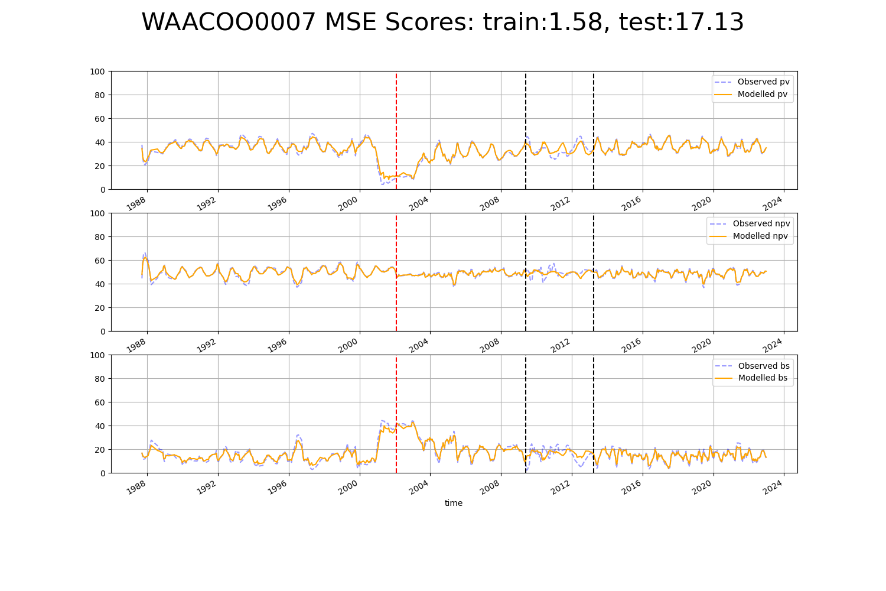

# WAAESP0001

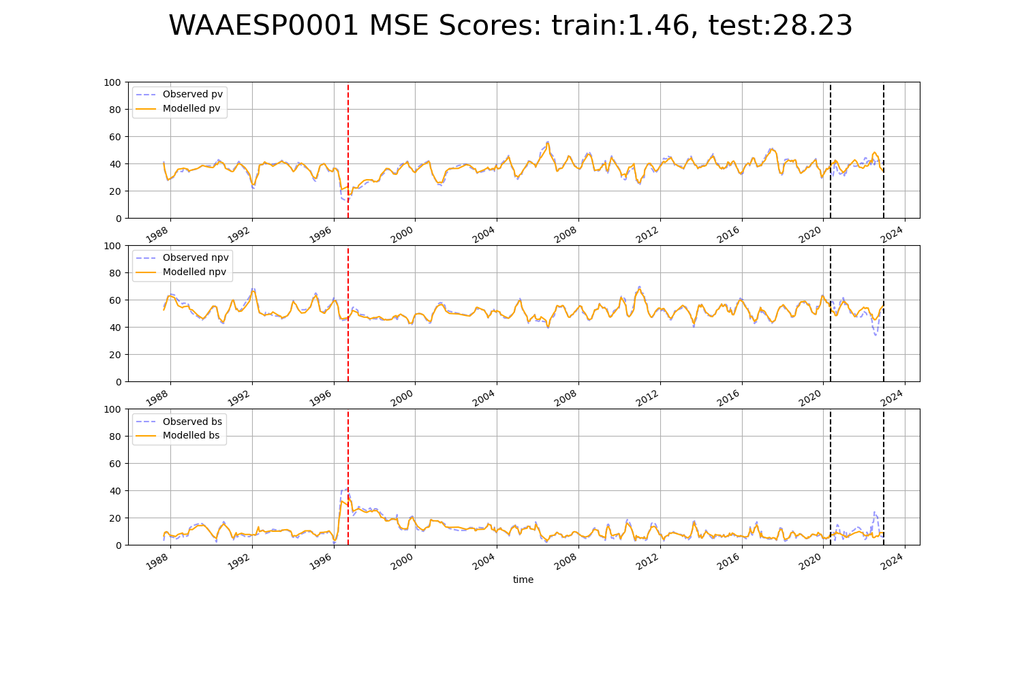

# WAAGES0001

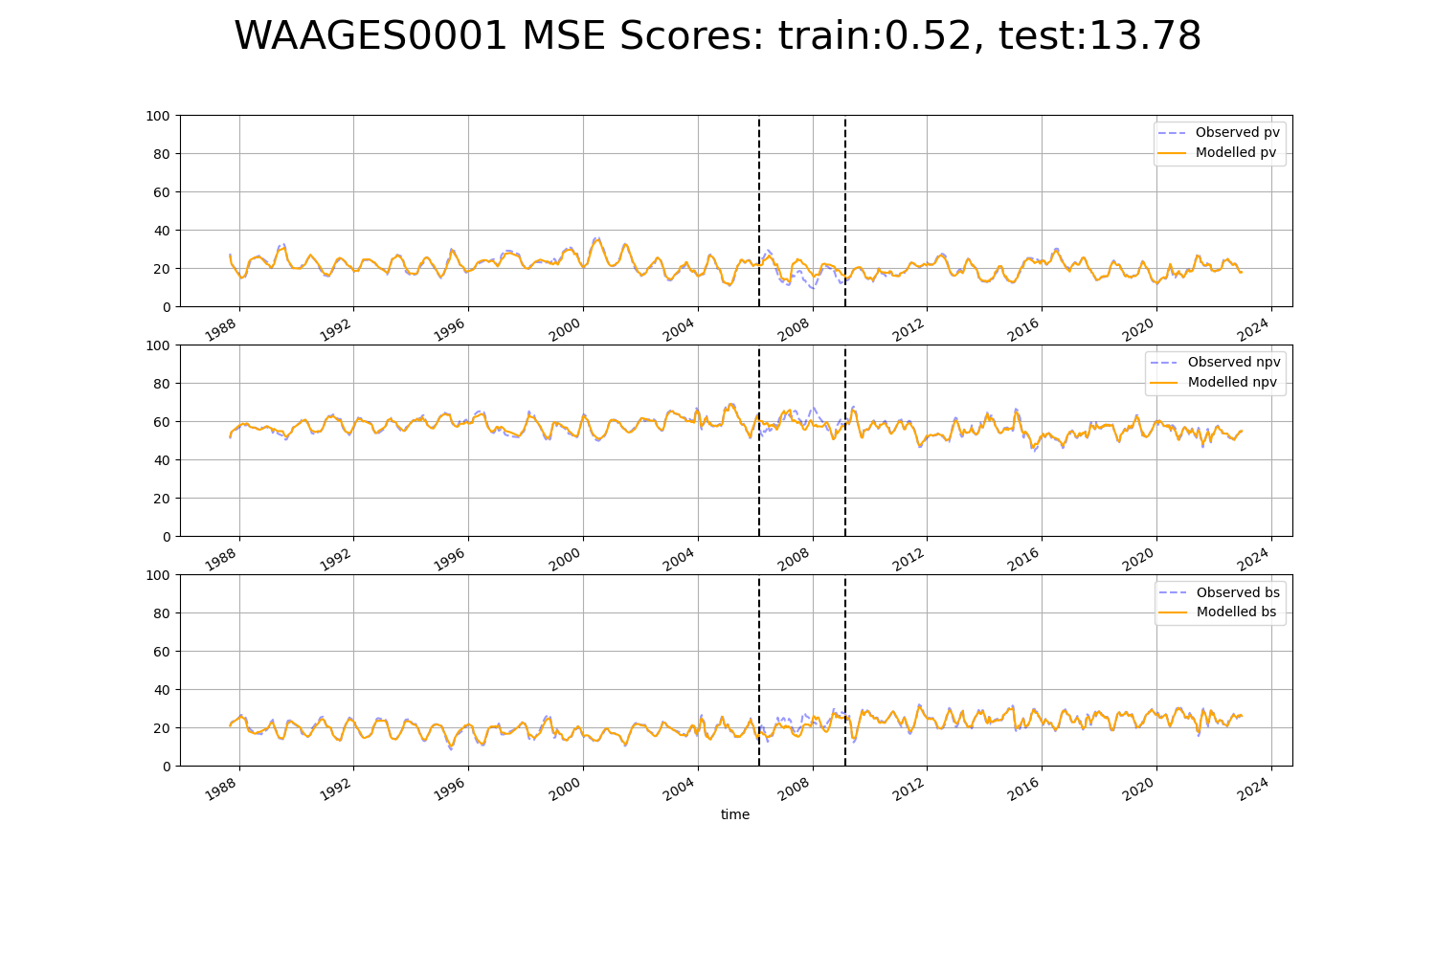

# WAAGES0002

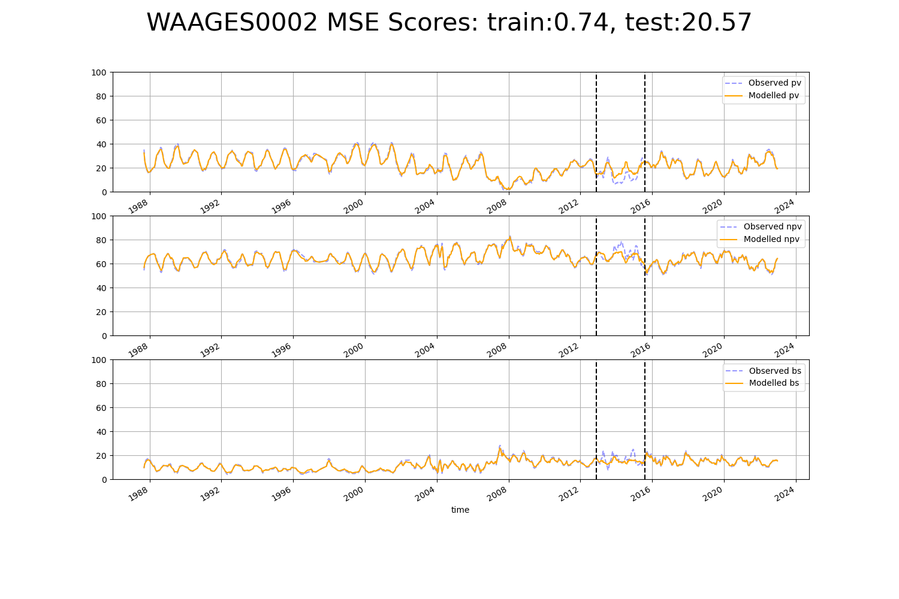

# WAAGES0003

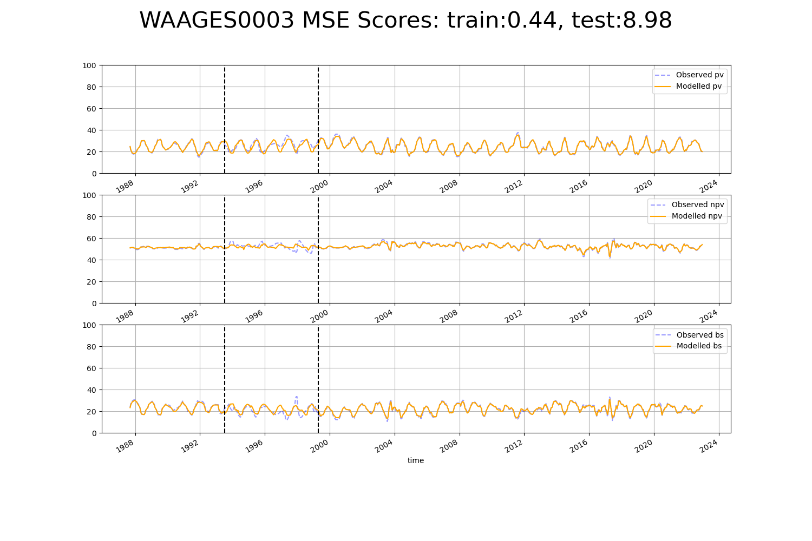

# WAAGES0005

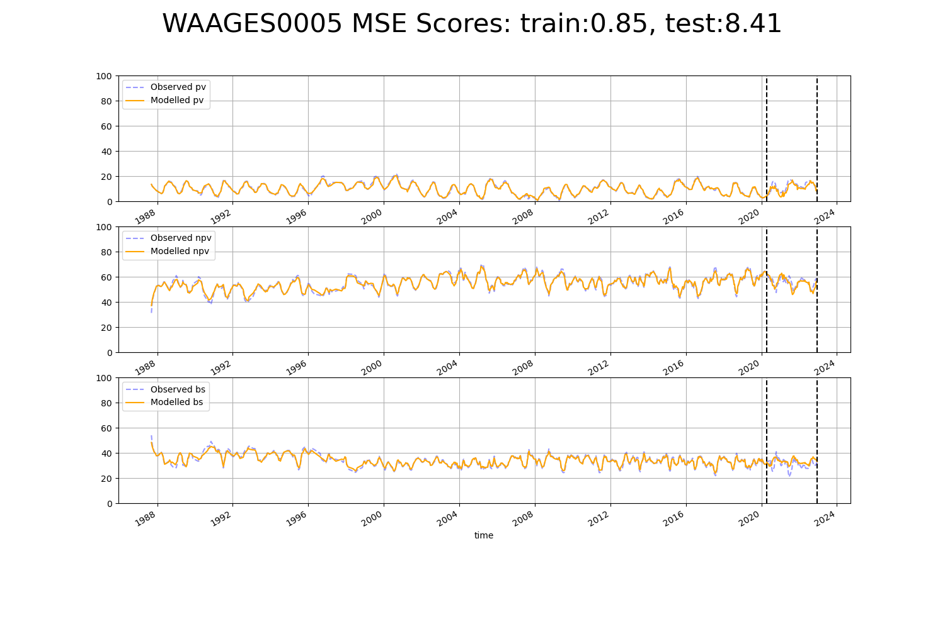

# WAAJAF0001

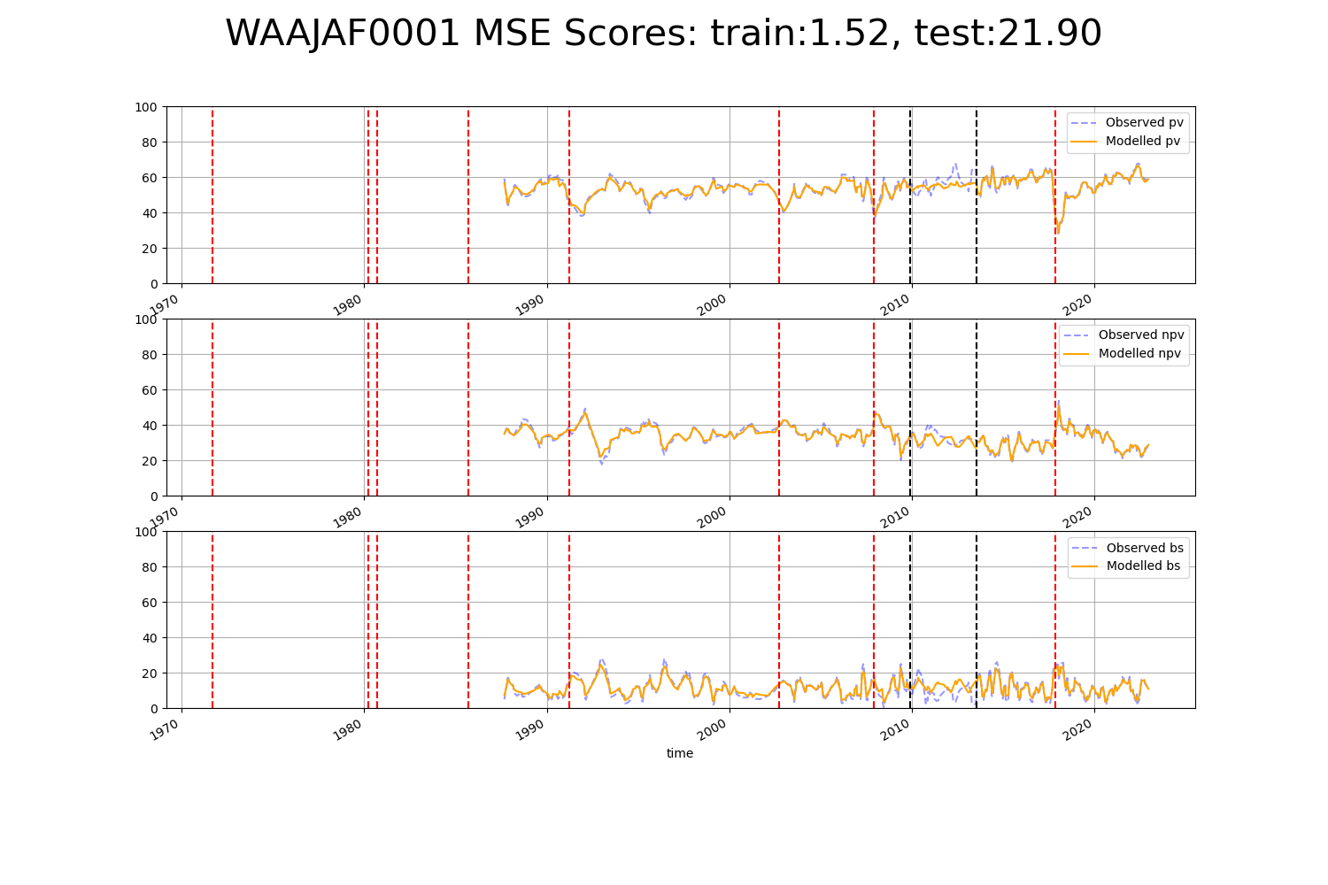

# WAAJAF0003

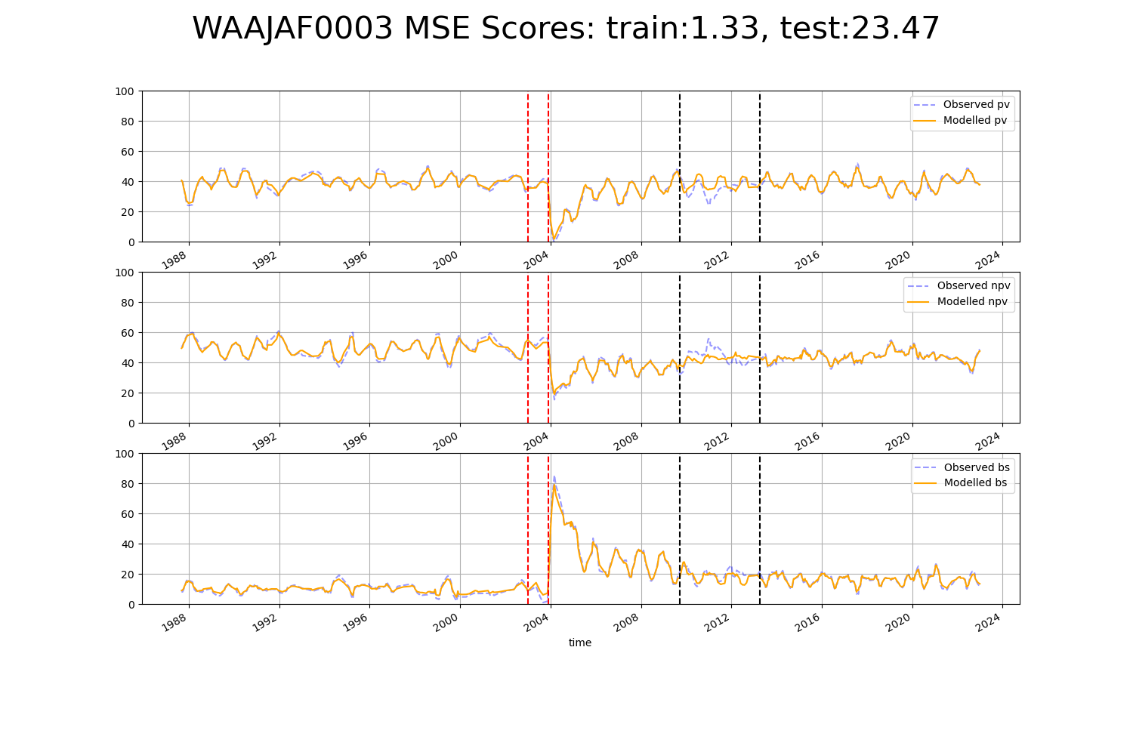

# WAAMAL0002

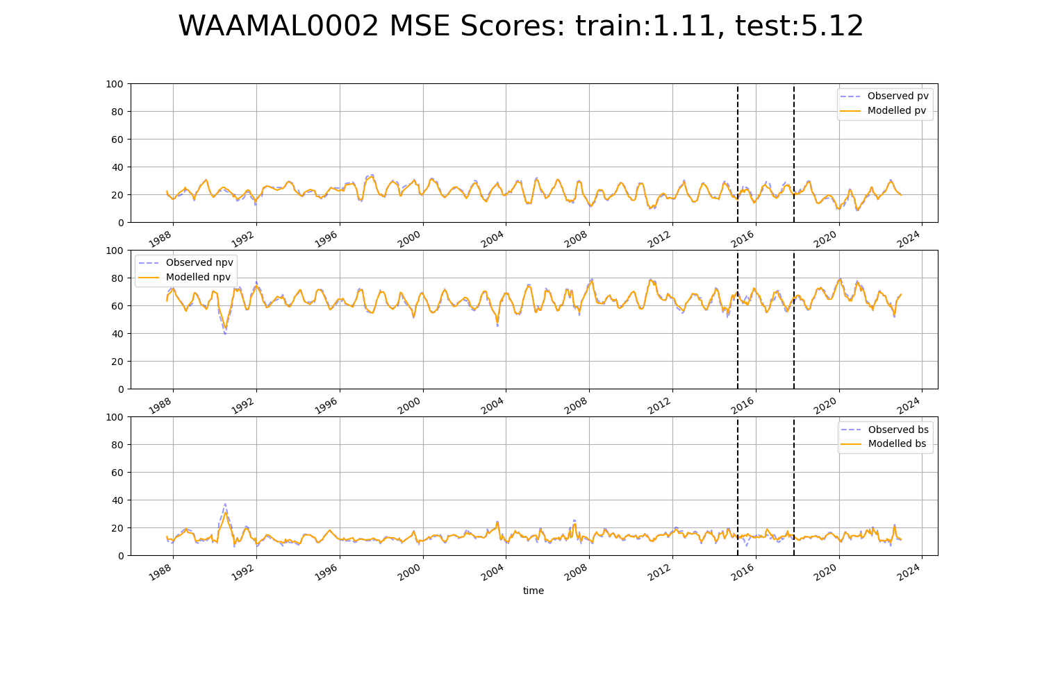

# WAAMAL0003

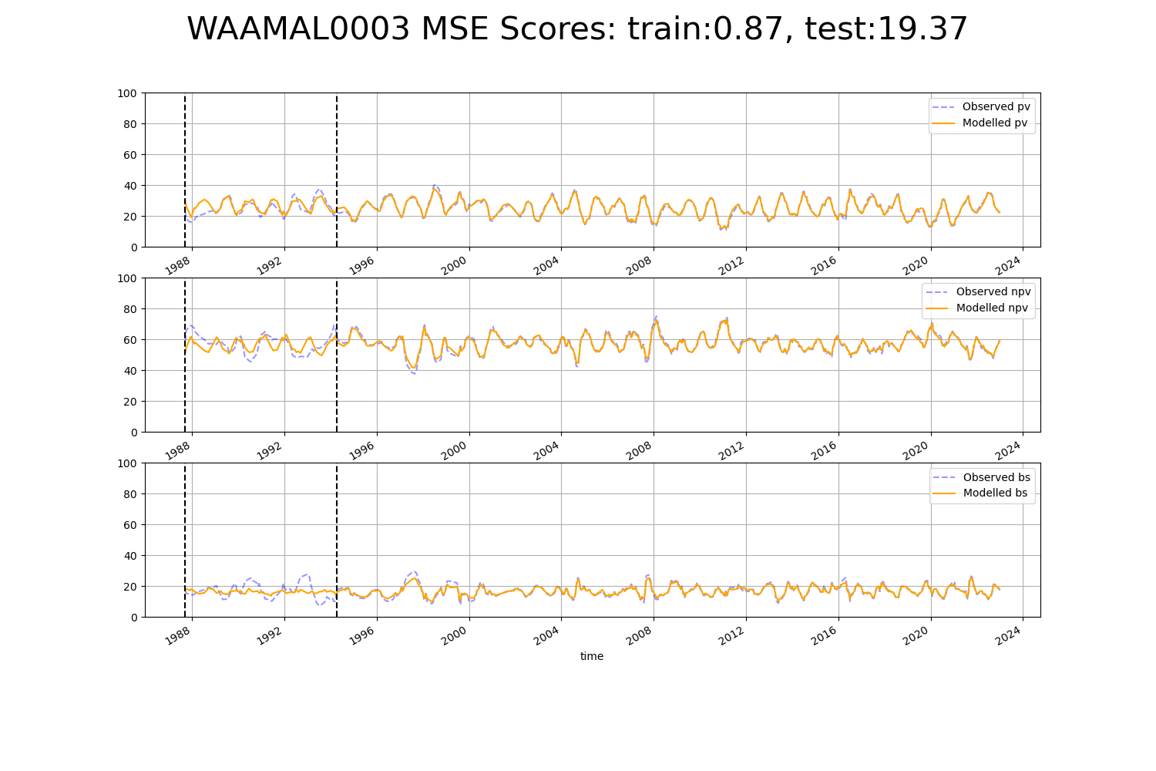

# WAAYAL0008

